# SUMMARY

Topic title: Price-support real estate business website

Student name: Nguyen Duc Van

Student ID: 102210195 Class: 21TCLC_DT2

In a rapidly growing real estate market, the demand for searching and trading properties has become more common than ever. However, many buyers still struggle to correctly assess the true value of a property, while sellers often find it difficult to set a competitive and reasonable price. Contacting brokers and referring to various scattered sources makes the buying and selling process more complicated, time-consuming prone to misinformation.

From that reality, this project aims to build a price-support real estate business website that helps users look up, postand search for properties based on their needs. Most importantly, it integrates a price recommendation system and future price prediction based on market data. This gives both buyers and sellers a reliable tool to make better decisions, save time and costsand improve transaction efficiency.

The website is mainly developed using JavaScript and Java. It applies machine learning to analyze data and suggest optimal pricing. The system also includes online payment integration and AI tools to check post content, such as verifying if images are appropriate for work environments.

In the introduction and Chapter 1, the project analyzes current user needs and challenges, the goals and features of the project, the target users, usage scopeand the technical background that supports the website’s development.

Chapter 2 covers business analysis, system designand database structure.

Chapter 3 presents the implementation and detailed descriptions of the features developed.

Chapter 4 evaluates the results, limitationsand future development directions.

Finally, lists the references used during the project.

I sincerely look forward to receiving feedback from my teachers and friends so that the system can be continuously improved.

|  |  |
| --- | --- |
| DA NANG UNIVERSITY  **UNIVERSITY OF SCIENCE AND TECHNOLOGY**  FALCUTY………………………………………… | **THE SOCIALIST REPUBLIC OF VIETNAM**  Independence - Freedom - Happiness |

# GRADUATION PROJECT REQUIREMENTS

Student Name: …..…………….………….…….. Student ID :………………...

Class:…………… Faculty:..................................... Major:…………...........................

1. *Topic title:*

………………………………………………..…………………………………………

…………………………………………………………………………………………..

1. *Project topic :* ☐*has signed intellectual property agreement for final result*
2. *Initial figure and data:*

……………………………………..……………………………………………..……......……………………………………………………………………………………………..………………………………….…..………………………..………………………*Content of the explanations and calculations:*

…...………………………………………………………………………………………

…...………………………………………………………………………………………

…...………………………………………………………………………………………

…...………………………………………………………………………………………

…...………………………………………………………………………………………

1. *Drawings, charts (specify the types and sizes of drawings):*

…...………………………………………………………………………………………

…...………………………………………………………………………………………

…...………………………………………………………………………………………

…...………………………………………………………………………………………

|  |  |
| --- | --- |
| 1. Name of instructor: | *Content parts:* |
|  |  |
|  |  |
|  |  |

1. *Date of assignment: ……../……./201…..*
2. *Date of completion: ……../……./201…..*

|  |  |
| --- | --- |
|  | *Đà Nẵng, date month year 201* |
| **Head of Division**…………………. | **Instructor** |

# PREFACE

# ASSURRANCE

I hereby declare that:

1. The graduation project report, Topic name: Real Estate Business System, is my own research work under the direct guidance of the lecturer MSc. Do Thi Tuyet Hoa.
2. I have read, researched, translated documentsand synthesized the knowledge that has made this reportand ensured that it has not been copied anywhere.
3. The theories in the thesis are all used from the documents as I have referred to in the reference section in the report.

If there is any violation, I will take full responsibility.

Student Performed

Nguyen Duc Van

# TABLE OF CONTENTS

SUMMARY 3

GRADUATION PROJECT REQUIREMENTS 4

PREFACE i

ASSURRANCE ii

TABLE OF CONTENTS iii

LIST OF PICTURES v

LIST OF TABLES vii

LIST OF SYMBOLS, ACRONYMS viii

INTRODUCTION 1

1. Purpose of implementation 1

2. Objective of the topic 1

2.1. System Target 1

2.2. Features 1

3. Scope 2

4. Target customers 2

5. Development technology 2

CHAPTER 1: THEORETICAL FOUNDATION 3

1.1. Overview of Python and Jupyter Notebook 3

1.1.1. Python 3

1.1.2. Jupyter Notebook 3

1.2. Overview of Java and MySQL 4

1.2.1. Java 4

1.2.2. Spring Boot 5

1.2.3. MVC model 5

1.2.4. MySQL 8

1.3. Overview of ReactJS and ChakraUI 9

1.3.1. React 9

1.3.2. ChakraUI 12

1.4. Chapter conclusion 12

CHAPTER 2: SYSTEM DESIGN AND ANALYSIS 13

2.1. Business analysis 13

2.1.1. Buyer's business 13

2.1.2. Broker's business 13

2.1.3. Admin's business 13

2.2. System design 14

2.2.1. Use-case diagram 14

2.2.2. Activity diagram 18

2.2.3. Sequence diagram 19

2.3. Database design 23

2.3.1. ER (entity-relationship) 23

2.3.2. Converting an implementation model into a system model 23

2.3.3. Database schema 29

2.4. Real estate prediction system development 30

2.4.1. Data crawling 30

2.4.2. Data cleaning 30

2.4.3. Feature Engineering 36

2.4.4. Real estate valuation model 39

2.4.5. Real estate price forecast model 40

2.5. Apply NSFW image and toxic content classification models 41

2.5.1. NSFW image classification models 41

2.6. Chapter conclusion 41

CHAPTER 3: IMPLEMENTATION AND RESULTS EVALUATION 42

3.1. Description of achieved functionalities 42

3.1.1. Customer-facing functionality 42

3.1.2. Admin-facing functionality 61

3.2. Chapter conclusion 65

CHAPTER 4: CONCLUSION AND DEVELOPMENT DIRECTION 65

REFERENCES 66

APPENDIX 1 1

APPENDIX 2 2

# LIST OF PICTURES

Figure 1.1 Python 3

Figure 1.2 Jupyter 3

Figure 1.3 Java 4

Figure 1.4 The compilation and interpretation process of Java 5

Figure 1.5 Spring Boot 5

Figure 1.6 Flow of operation in the MVC model 6

Figure 1.7 Three-tier architecture 7

Figure 1.8 Three-Tier architecture vs MVC pattern 8

Figure 1.9 MySQL 8

Figure 1.10 React 9

Figure 1.11 How React uses Virtual DOM 10

Figure 1.12 ReactJS lifecycle 11

Figure 1.13 Chakra UI 12

Figure 2.1 General use case diagram 14

Figure 2.2 User management use-case diagram 14

Figure 2.3 Post moderation use case diagram 15

Figure 2.4 Profile management use case diagram 15

Figure 2.5 Account upgrade management use case diagram 16

Figure 2.6 Post management use case diagram 16

Figure 2.7 Favourite post management use case diagram 17

Figure 2.8 Client Operation Principle 18

Figure 2.9 Admin Operation Principle 18

Figure 2.10 Registration/Login Flow 19

Figure 2.11 Real estate article management flow as a user 21

Figure 2.12 Account upgrade flow 22

Figure 2.13 The ER entity relationship model 23

Figure 2.14 Relational Model 29

Figure 2.15 Statistics to check features with values less than 0 30

Figure 2.16 Statistics of missing values 30

Figure 2.17 Distribution of rows based on the number of missing values 31

Figure 2.18 Width distribution before and after preprocessing 31

Figure 2.19 Length distribution before and after preprocessing 32

Figure 2.20 Direction distribution before and after preprocessing 32

Figure 2.21 Property features distribution before and after preprocessing 33

Figure 2.22 Floor distribution before and after preprocessing 33

Figure 2.23 Toilet distribution before and after preprocessing 34

Figure 2.24 Furnishing sell distribution before and after preprocessing 34

Figure 2.25 Real estate valuation model features 35

Figure 2.26 Real estate price forecast features 35

Figure 2.27 Histogram plots of feature distributions 36

Figure 2.28 Visual Comparison of Outlier Impact on Feature Distributions 36

Figure 2.29 Q-Q Plots after optimal normalization per feature 37

Figure 2.30 Comparison of Q-Q Plots of Price per m² across different transformation methods 37

Figure 2.31 Scatter plot of features vs. Price 38

Figure 2.32 Selected features in order from best to worst. 38

Figure 2.33 Optimal number of features 39

Figure 2.34 Recursive Feature Elimination with correlated features 39

Figure 2.35 Scatter plot of actual vs. predicted real estate prices on the test set 40

Figure 2.36 Scatter plot of actual vs. predicted real estate prices per m2 on the test set 41

Figure 3.1 Login interface 43

Figure 3.2 Register interface 44

Figure 3.3 Post list interface 46

Figure 3.4 Search filter interface when selecting “Land” as the property type 46

Figure 3.5 Search filter interface when selecting “House” as the property type 46

Figure 3.6 The post detail interface 48

Figure 3.7 The love post detail interface 49

Figure 3.8 Favorite post deletion confirmation popup 50

Figure 3.9 Property type select box 51

Figure 3.10 Add new post interface 52

Figure 3.11 Profile information interface 55

Figure 3.12 Personal post list interface 56

Figure 3.13 Personal post deletion confirmation popup 56

Figure 3.14 Property feature input interface for forecasting 57

Figure 3.15 Forecast result interface 57

Figure 3.16 Upgrade account interface 59

Figure 3.17 VNPay online payment gateway interface. 59

Figure 3.18 Transaction history interface 60

Figure 3.19 Post list interface 61

Figure 3.20 Post moderation interface 62

Figure 3.21 Account status modification interface 63

Figure 3.22 User status change confirmation pop-up 64

# LIST OF TABLES

Table 2.1 Describe role table attributes 23

Table 2.2 Describe user table attributes 24

Table 2.3 Describe token table attributes 24

Table 2.4 Describe transaction histories table attributes 24

Table 2.5 Describe favourite properties of table attributes 25

Table 2.6 Describe category table attributes 25

Table 2.7 Describe property table attributes 25

Table 2.8 Describe house table attributes 26

Table 2.9 Describe furnished status table attributes 26

Table 2.10 Describe type of house table attributes 27

Table 2.11 Describe house characteristics table attributes 27

Table 2.12 Describe house characteristic mapping table attributes 27

Table 2.13 Describe land table attributes 27

Table 2.14 Describe type of land table attributes 28

Table 2.15 Describe land characteristics table attributes 28

Table 2.16 Describe land characteristic mapping table attributes 28

Table 2.17 Evaluation metrics table for the real estate valuation models 39

Table 2.18 Evaluation metrics table for the real estate price forecast models 40

Table 3.1 Login function specification 43

Table 3.2 Register function specification 44

Table 3.3 Function specifications for the post list 46

Table 3.4 Function specifications for the post detail 48

Table 3.5 Function specifications for the favourite post list 50

Table 3.6 Add new post function specification 52

Table 3.7 Update profile function specification 55

Table 3.8 Function specifications for the personal post list 56

Table 3.9 Forecast property price function specification 57

Table 3.10 Function specifications for upgrading the account 59

Table 3.11 Function specifications for showing transaction history 60

Table 3.12 Function specifications for post moderation 62

Table 3.13 Function specifications for post moderation 64

# LIST OF SYMBOLS, ACRONYMS

|  |  |
| --- | --- |
| Symbol, Acronym | Detailed explanation |
| PMML | Predictive Model Markup Language |
| HTTPS | HyperText Transfer Protocol Secure |
| PKL | Extension for files created with Pickle |
| API | Application Programming Interface |
| ONNX | Open format for storing machine learning models |
| NSFW | Not safe for work |
| XML | eXtensible Markup Language |
| CSS | Cascading Style Sheets |
| HTML | HyperText Markup Language |
| WAR | Web Application Archive |
| JPA | Java Persistence API |
| DOM | Document Object Model |
| **ACID** | Atomicity, Consistency, Isolation, Durability |
| **JSX** | JavaScript XML |

# INTRODUCTION

## Purpose of implementation

* Searching and buying real estate today is difficult, especially in determining the real value of the property, comparing suitable options and accessing transparent information. Buyers often spend a lot of time searching for properties that meet their needs in terms of location, area, amenities and finance, while sellers have difficulty reaching potential customers.
* Therefore, an online real estate business system can help display information visually, support filtering and comparing optionsand integrate price prediction technology to help buyers and sellers make more accurate decisions

## Objective of the topic

### System Target

* Help users quickly post and search for suitable real estate based on filters with many characteristics.
* The real estate valuation feature provides a reference price close to the market, helping users minimize the risk of incorrect valuation, supporting the brokerage team or real estate sellers and buyers to save time in valuation and negotiation.
* The system will also support predicting real estate fluctuations to support customers' buying or selling decisions.
* When a post is uploaded to the system, its content and images will also be checked to ensure they are safe for the workplace environment.
* Integrating VNPay, a safe and convenient online payment when customers want to upgrade their account to use more features of the application.

### Features

* For guests
  + Search and filter by needs: price, area, location, property type, etc.
  + View property details with images, prices and legal information, etc.
  + Displays detailed information about the property along with the price determined by the property valuation system.
* For members
  + Post real estate with full information: images, descriptions, prices, legal status, …; however, the number of posts will be limited to 3.
  + You can save posts that interest you as well as upgrade your account to be able to use more features of the application.
* For brokers
  + Customers with upgraded accounts will be supported by the system to forecast real estate prices in the future.
  + The number of posts posted by the brokerage account will also be up to 30.
* For admins:
  + Update account status.
  + View article details and moderate it.

## Scope

* Property type: house, land.
* Geographical scope: Da Nang
* Language: Vietnamese

## Target customers

* Real Estate Buyers/Sellers
* Real Estate Companies or Brokers

## Development technology

* Project management: GitHub
* Language: Java, Python, ReactJS
* Framework: Spring Boot
* Database: MySQL
* Encryption & security: Security, HTTPS Token

# THEORETICAL FOUNDATION

## Overview of Python and Jupyter Notebook

### Python

Python is a widely used high-level programming language applied in web development, software engineering, data scienceand machine learning (ML). Developers favor it due to its simplicity, efficiencyand cross-platform compatibility.



Figure . Python

**Benefits of Python include:**

* Developers can easily read and understand Python programs because the language has a simple syntax that resembles English.
* Python improves developer productivity as fewer lines of code are typically needed to write a program compared to other programming languages.
* Python has a large standard library that contains reusable code for almost any task, so developers don't need to write everything from scratch.
* Developers can easily integrate Python with other popular programming languages such as Java, Cand C++.
* Python is cross-platform and can be used on various operating systems, including Windows, macOS, Linuxand Unix.

### Jupyter Notebook

Jupyter Notebook is an open-source web application that allows users to create and share documents containing code, equations, visualizationsand narrative text. It is widely used in data science, machine learning, academic researchand educational settings.



Figure . Jupyter

Benefits of Jupyter Notebook:

* Jupyter allows users to run code in small chunks, making it ideal for testing and debugging.
* The integration with libraries like Matplotlib, Seabornand Plotly makes visualizing data easy within the notebook itself.
* Users can mix narrative text (using Markdown) with code and outputs, creating comprehensive reports or tutorials.
* Notebooks make it easy to share code, dataand results, ensuring that research is reproducible.

## Overview of Java and MySQL

### Java

Java is a class-based, object-oriented programming language that is designed to have as few implementation dependencies as possible. It is intended to let application developers Write Once and Run Anywhere (WORA), meaning that compiled Java code can run on all platforms that support Java without the need for recompilation. Java was developed by James Gosling at Sun Microsystems Inc. in May 1995 and later acquired by Oracle Corporationand is widely used for developing applications for desktop, weband mobile devices.



Figure . Java

Java is known for its simplicity, robustnessand security features, making it a popular choice for enterprise-level applications. Java applications are compiled to bytecode that can run on any Java Virtual Machine. The syntax of Java is similar to C/C++.

Since Java runs on the JVM, it may not be as fast as languages that are compiled directly, such as C/C++. This can be a concern for applications that require high performance.

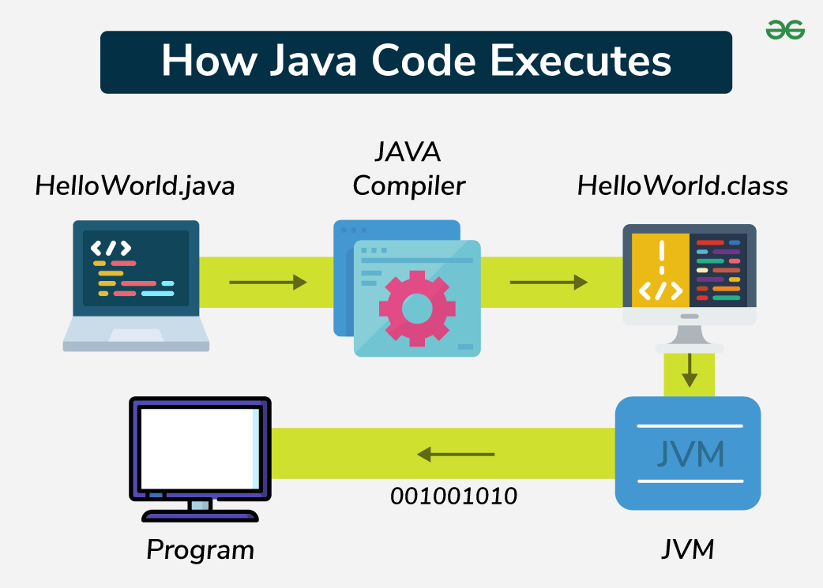

Figure . The compilation and interpretation process of Java

### Spring Boot

Spring Boot is a combination of the Spring Framework and an embedded server, allowing you to build web applications, microservicesand standalone JAR applications. It supports features like Microservices, REST APIand JPA databases, making app development simpler and more efficient.



Figure . Spring Boot

Advantages of Spring Boot:

* It creates standalone Spring applications.
* It makes testing web apps easier with embedded HTTP servers like Tomcat, Jettyand others. No need to distribute WAR files.
* No XML configuration required.

### MVC model

* **MVC** stands for **Model-View-Controller**.
* It is a design pattern used in software engineering.
* MVC is a software architecture pattern used to create computer user interfaces.
* MVC is divided into three connected parts; each part has its responsibility and works independently from the others.
  + **Model**
    - Responsible for working with the **database**.
    - It contains all the functions and methods that directly query or update the data.
    - The **Controller** uses these functions to get data and sends it to the **View**.
  + **View**
    - The **user interface**.
    - Contains all the elements that the user interacts with, such as menus, buttons, images, text, etc.
    - Receives data from the **Controller** and displays it.
  + **Controller**
    - Acts as the **middle layer** between Model and View.
    - Handles user requests, uses the **Model** to get dataand then passes that data to the **View** to show to the user.

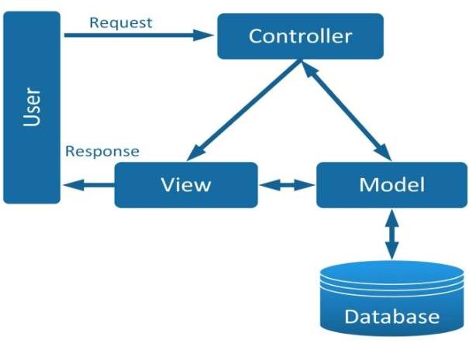

Figure . Flow of operation in the MVC model

* MVC workflow
  + First, a request from the user is sent from the client to the server.
  + Then, the Controller, based on the user’s request, communicates with the Model to get the required data from the database.
  + Finally, the Controller sends the retrieved data to the View, which displays it to the user in the browser.
* Three-tier model: This is a common source code structure used in Spring Boot applications. Specifically, the application is divided into three tiers (or layers) as follows:
  + Presentation layer: This layer interacts directly with the user. It can include Views and Controllers (in traditional MVC) or APIs (in RESTful applications).
  + Business logic layer: This layer contains the core logic of the application. Most of the application’s code resides here. It is responsible for processing data and enforcing business rules.
  + Data access layer: This layer interacts directly with the database, executing queries and returning results to the business logic layer.

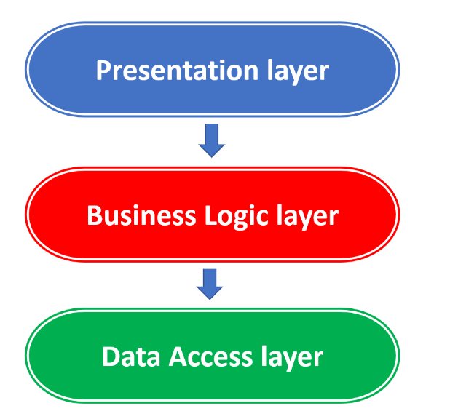

Figure . Three-tier architecture

* By combining the two models, we get a complete Spring Boot application consisting of the following components:
  + Controller: The controller returns a View (which contains the data ready for display in HTML format) or a Model represented through an API for the View (the View is separately written using React, Vue or Angular).
  + Service: The Service contains the logic and processing code. When the Controller requests it, the Service will handle the request and return the data (in the form of a Model) back to the Controller. The Controller will then pass this data to the View as described earlier.
  + Repository: The Repository is used by the Service to interact with the database. The Repository directly interacts with the database, reading and writing dataand then returning the results to the Service.

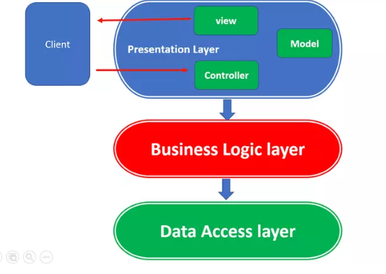

Figure . Three-Tier architecture vs MVC pattern

### MySQL

* MySQL is an open-source, relational database management system (RDBMS) that uses Structured Query Language (SQL) to manage and manipulate data. It is one of the most popular database systems used in web applications, known for its speed, reliabilityand ease of use.



Figure . MySQL

* Key Features of MySQL:
  + **Developed by Oracle Corporation.**
  + **Supports multiple platforms**: MySQL runs on operating systems such as Windows, Linuxand macOS.
  + **Widely used by developers** due to its scalability, data security featuresand large community support.
* Advantages of MySQL:
  + **Open-source**: MySQL is free and open-source, allowing modification and redistribution.
  + **High performance**: MySQL offers fast data retrieval and processing for large datasets.
  + **ACID compliance**: Ensures data integrity and reliability, especially with the InnoDB storage engine.
  + **Scalability**: It supports large databases and high traffic with features like partitioning and clustering.
  + **Variety of storage engines**: MySQL offers multiple storage engine options (e.g., InnoDB, MyISAM) for flexible usage.
  + **Replication**: It supports master-slave replication for data redundancy and high availability.

## Overview of ReactJS and ChakraUI

### React

* React (ReactJS) is a free and open-source JavaScript library for building web user interfaces. It handles only the visual part (the view) and does not control how business logic or app structure is organized.



Figure . React

* Key feature of React
  + **Virtual DOM**:
    - Creates a lightweight copy of the DOM.
    - Compares it with the previous version to detect changes (diffing).
    - Updates only the changed parts in the actual DOM (reconciliation), improving performance.
  + **Components** are the basic building blocks of React that define the structure of the user interface. Each component is encouraged to be as small and independent as possible to allow for easy reuse across different parts of the application or even in other applications.
  + **JSX** is a syntax extension that allows you to write HTML-like code within JavaScript. In other languages, HTML and JavaScript are typically written separately. However, with JSX, React lets you combine both in the same source code file.
  + React uses **one-way data binding**, meaning data flows in a single direction from parent components to child components via props. This provides better control over data and helps maintain predictable behavior.
* React operates by creating an in-memory virtual DOM rather than directly manipulating the browser’s DOM. It performs necessary manipulations within this virtual representation before applying changes to the actual browser DOM.

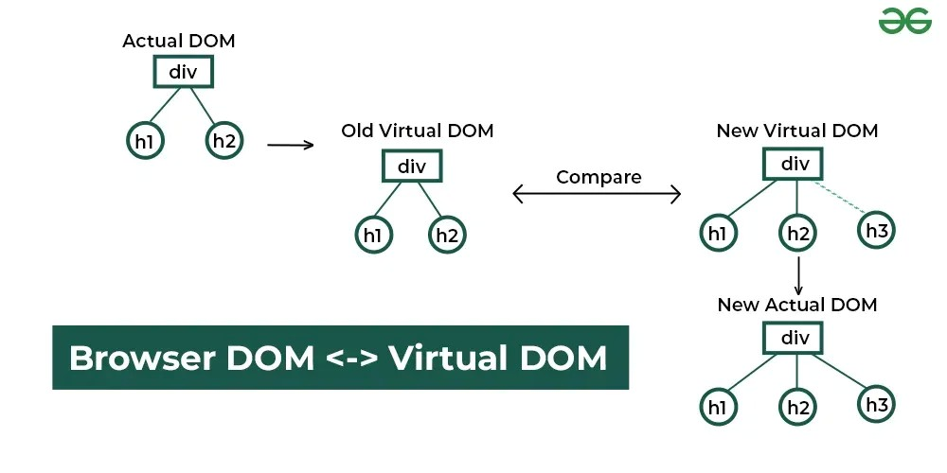

Figure . How React uses Virtual DOM

* Here’s how the process works:
  1. Actual DOM and Virtual DOM
     + Initially, an Actual DOM contains a div with two child elements: h1 and h2.
     + React maintains a previous Virtual DOM to track the UI state before any updates.
  2. Detecting Changes
     + When a change occurs (e.g., adding a new h3 element), React generates a New Virtual DOM.
     + React compares the previous Virtual DOM with the New Virtual DOM using a process called reconciliation.
  3. Efficient DOM Update
     + React identifies the differences (in this case, the new h3 element).
     + Instead of updating the entire DOM, React updates only the changed part in the New Actual DOM, making the update process more efficient.
* ReactJS lifecycle

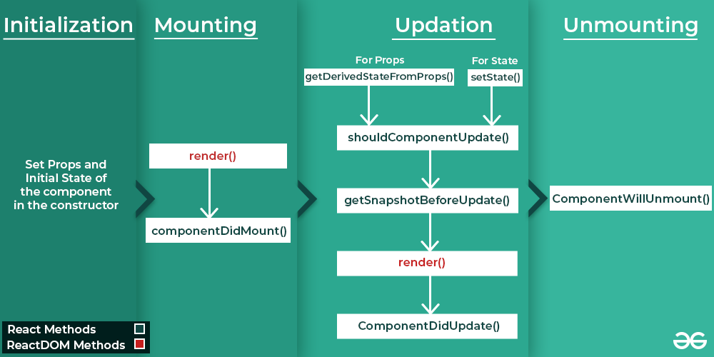

Figure . ReactJS lifecycle

* 1. Initialization: This is the stage where the component is constructed with the given Props and default state. This is done in the constructor of a Component Class.
  2. Mounting Phase
     + Constructor: The constructor method initializes the component. It’s where you set up the initial state and bind event handlers.
     + **render():** This method returns the JSX representation of the component. It’s called during initial rendering and subsequent updates.
     + **componentDidMount()**: After the component is inserted into the DOM, this method is invoked. Use it for side effects like data fetching or setting timers.
  3. Updating Phase
     + **componentDidUpdate(prevProps, prevState)**: Called after the component updates due to new props or state changes. Handle side effects here.
     + **shouldComponentUpdate(nextProps, nextState)**: Determines if the component should re-render. Optimize performance by customizing this method.
     + **render():** Again, the render() method reflects changes in state or props during updates.
  4. Unmounting Phase
     + **componentWillUnmount()**: Invoked just before the component is removed from the DOM. Clean up resources (e.g., event listeners, timers).

### ChakraUI

* Chakra UI is a modern, modularand accessible component library for React applications. Its main goal is to simplify the development of user interfaces by providing a set of pre-built, composableand themeable components that follow best practices for accessibility and responsive design.
* Unlike traditional UI libraries that often require developers to write a lot of custom CSS or rely on additional styling tools, Chakra UI is built with a focus on developer experience. It uses a style props system that allows developers to apply CSS directly to components using simple and intuitive syntax, reducing or even eliminating the need for separate stylesheets.
* With Chakra UI, you can easily build sleek, modern interfaces that are highly customizable and compliant with UI/UX standards. The library offers a wide range of commonly used components such as buttons, forms, navigation bars, modalsand more—helping you get started quickly without having to build everything from scratch.



Figure . Chakra UI

## Chapter conclusion

In this chapter, I reviewed key technologies and frameworks essential for modern software development. I covered popular programming languages like Python and Java, tools such as Jupyter Notebookand powerful frameworks like Spring Boot with its MVC and three-tier architecture.

I also discussed MySQL’s strengths as a reliable and scalable database system. On the frontend side, we introduced ReactJS with its component-based design and Virtual DOM, along with Chakra UI for faster and easier UI development.

Together, these technologies form a solid foundation for building effective and maintainable applications today.

# SYSTEM DESIGN AND ANALYSIS



## Business analysis

### Buyer's business

* **Visiting customers**
  + View property list: can view all properties posted on the system.
  + View property details: view description, images, price, area, number of rooms, etc. At the same time, the real estate price will be displayed as determined by the system.
  + Register account: if you want to save posts or make transactions, visitors must register an account.
  + Search and filter properties: Search by keywords, filter by characteristics of the property.
* **Members** are those who have registered an account and can use all the features:
  + All rights of visitors.
  + Update profile and account information: Change contact information and full name.
  + Upgrade account: choose an account upgrade package to use more features and pay directly through the payment gateway.
  + View transaction history: track completed or pending transactions.
  + Buyer accounts can also post properties for sale, but are limited to 3
  + Manage personal post: edit, update and delete an uploaded real estate post.
  + Save to favorites: add properties to your favorites list for easy access later.

### Broker's business

* Brokerage account is a registered and upgraded account
* Having all the rights of a member
* This account will be used for additional features of the system: predicting real estate trends.
* The article limits the posts that can be posted by this account to 30

### Admin's business

* Account status control: lock or unlock client accounts.
* Post moderation: review, approve or reject real estate posts.

## System design

### Use-case diagram

#### General use-case diagram

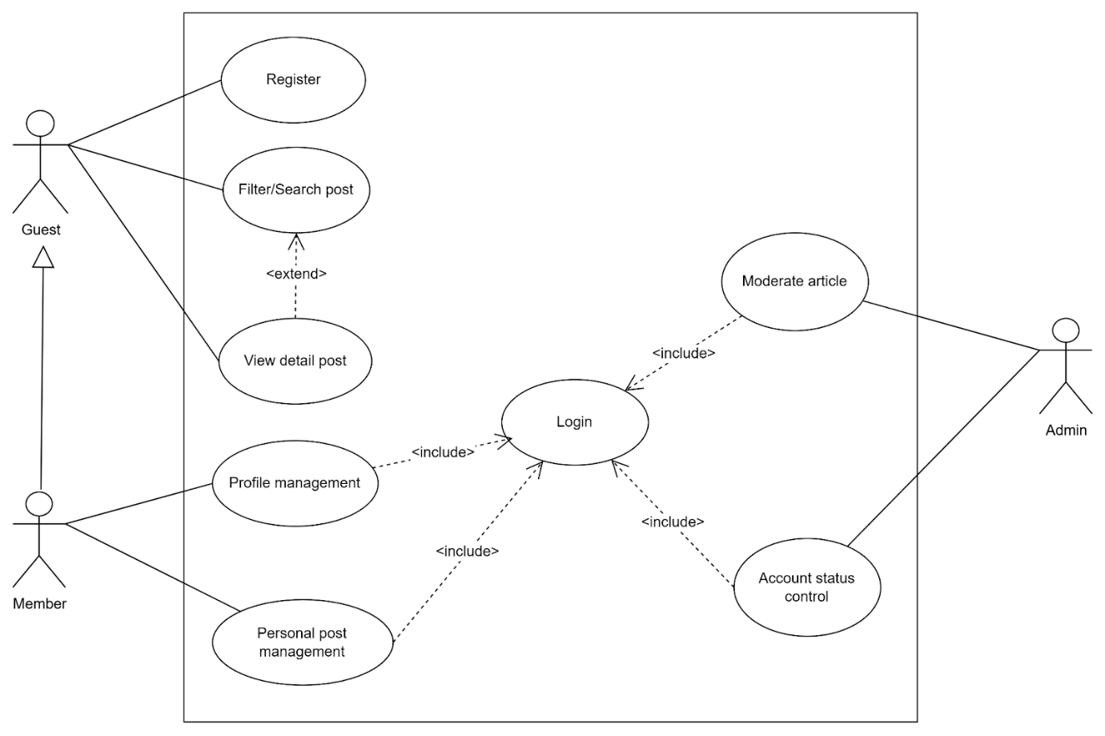

Figure . General use case diagram

#### Admin use-case diagram

* Account status control

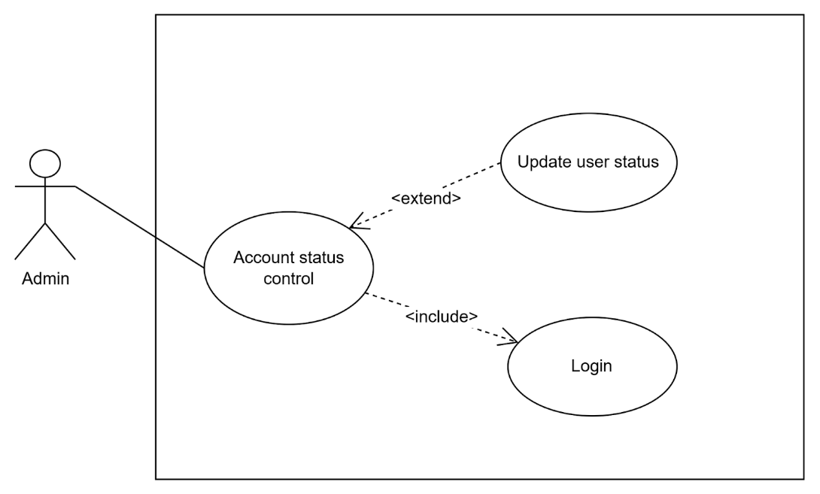

Figure . User management use-case diagram

* Post moderation

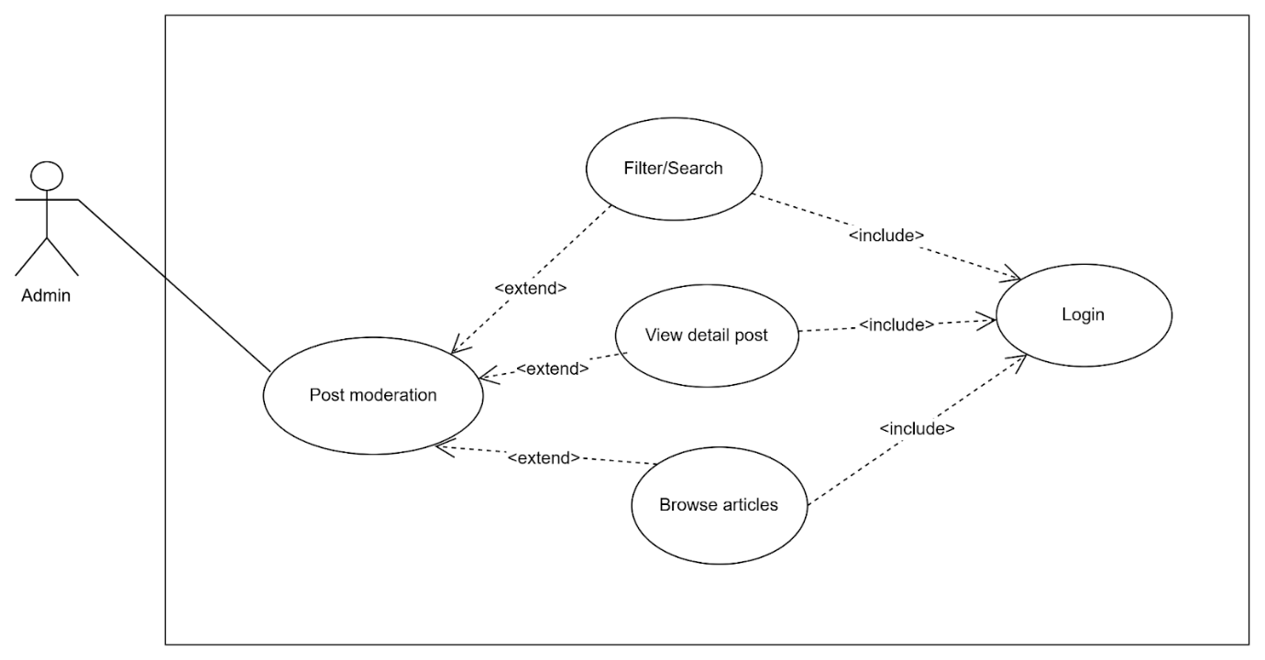

Figure . Post moderation use case diagram

#### User use-case diagram

* Profile management

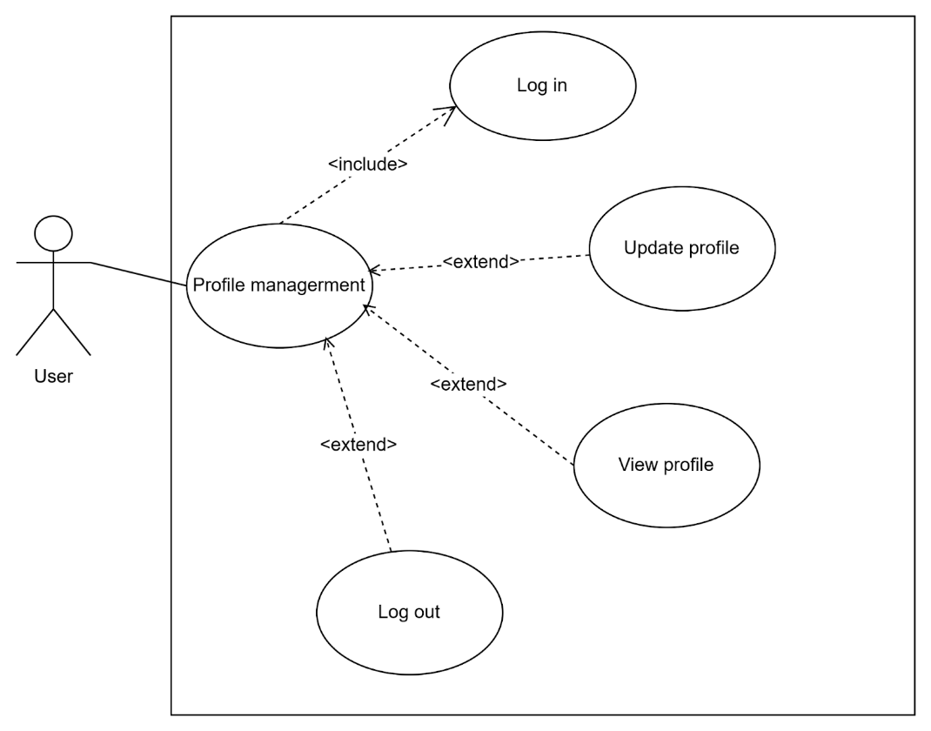

Figure . Profile management use case diagram

* Account upgrade management

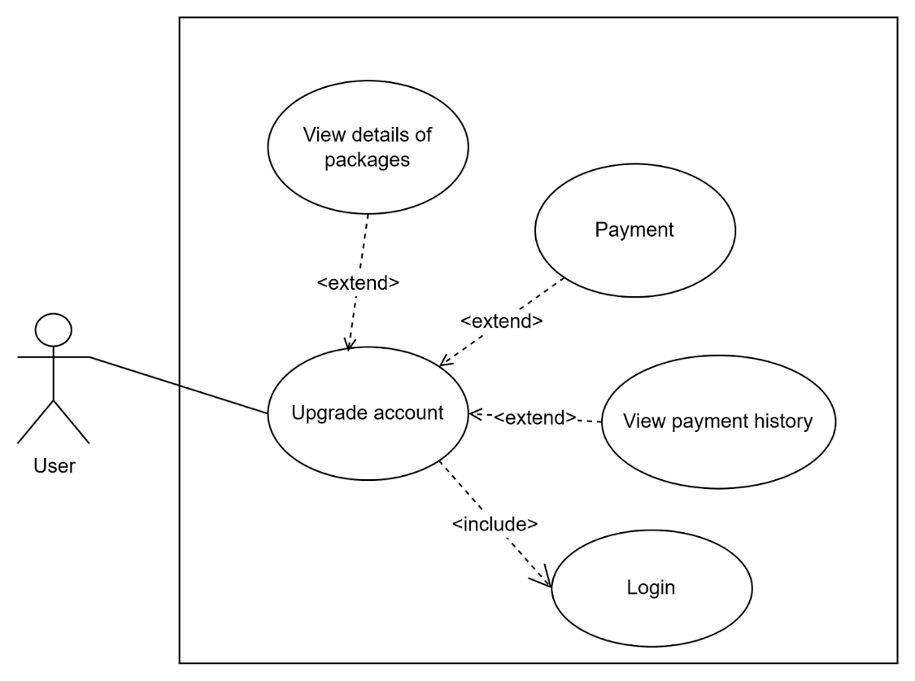

Figure . Account upgrade management use case diagram

* Post management

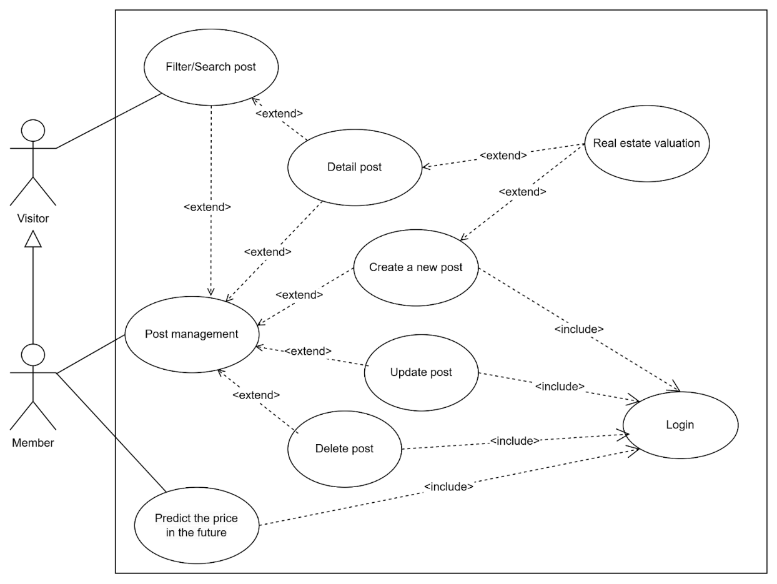

Figure . Post management use case diagram

* Favourite post management

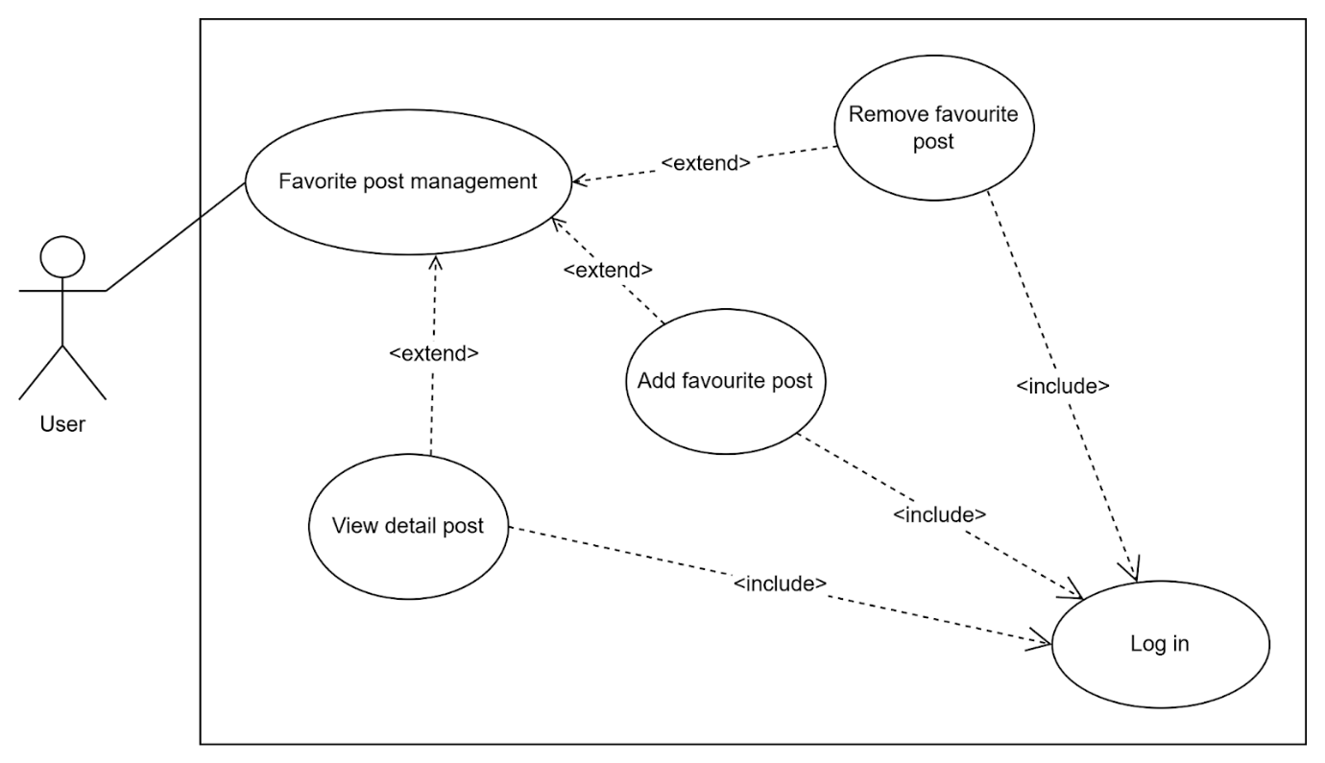

Figure . Favourite post management use case diagram

### Activity diagram

* The stream of activities provides access to the buyer/seller's website

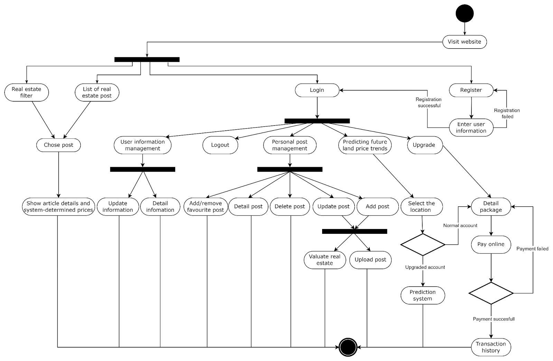

Figure . Client Operation Principle

* The stream of activities provides access to the admin website

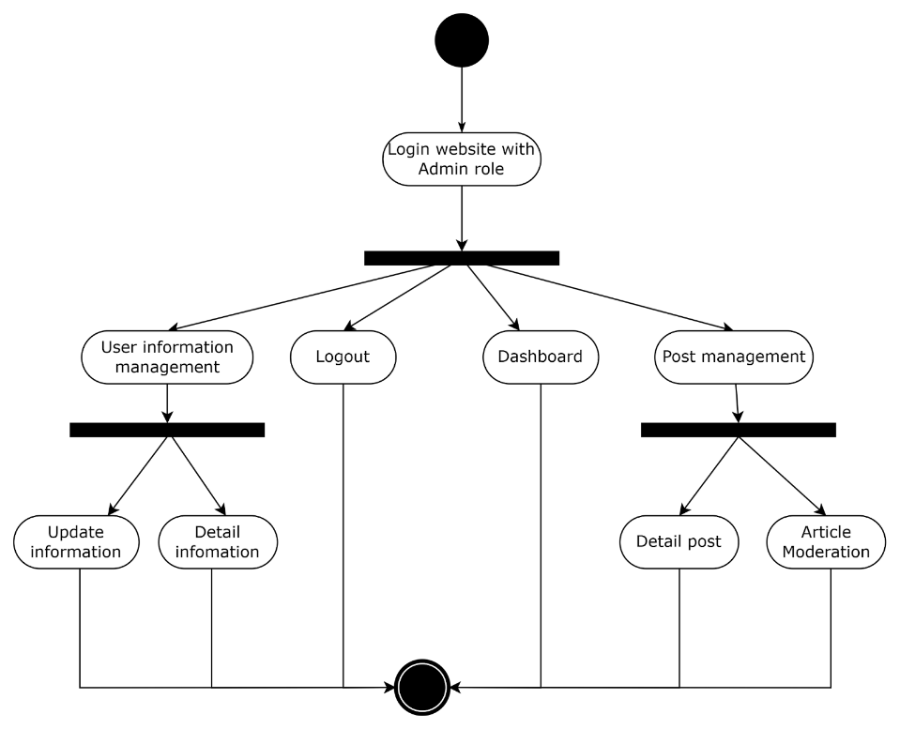

Figure . Admin Operation Principle

### Sequence diagram

* Login/Signup flow design

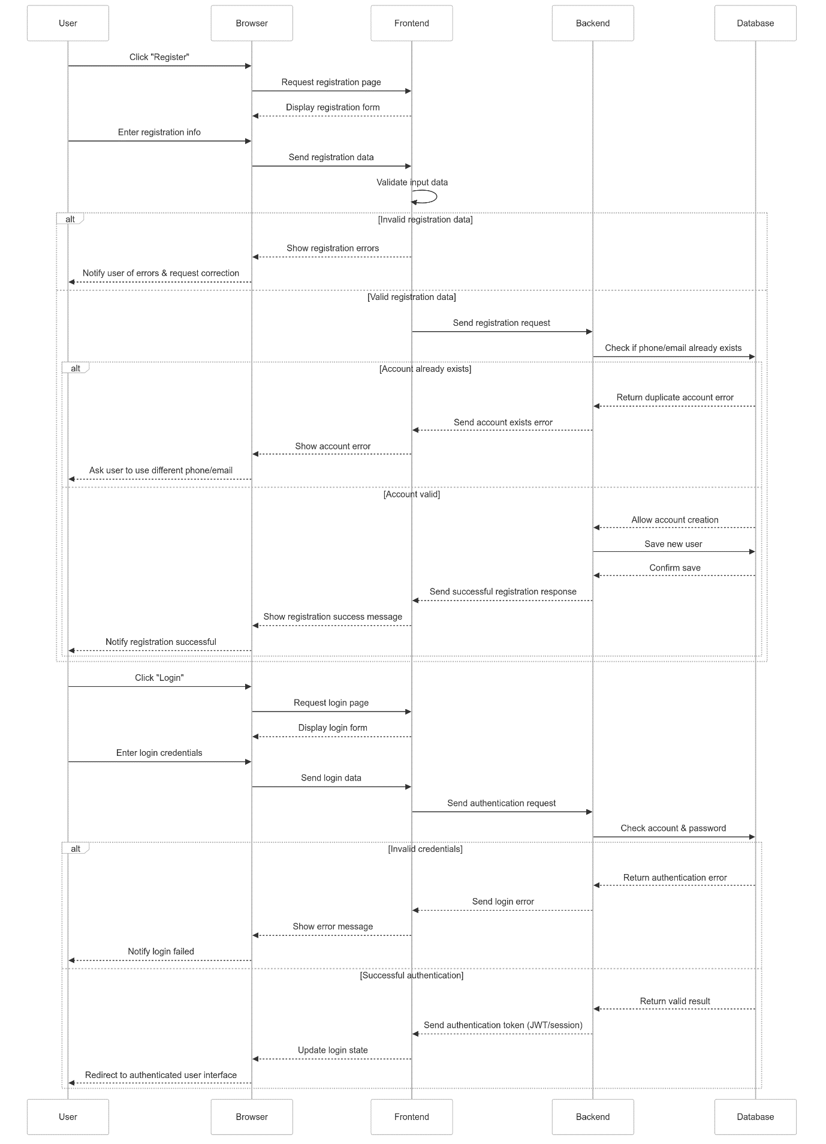

Figure . Registration/Login Flow

* Real estate article management flow design

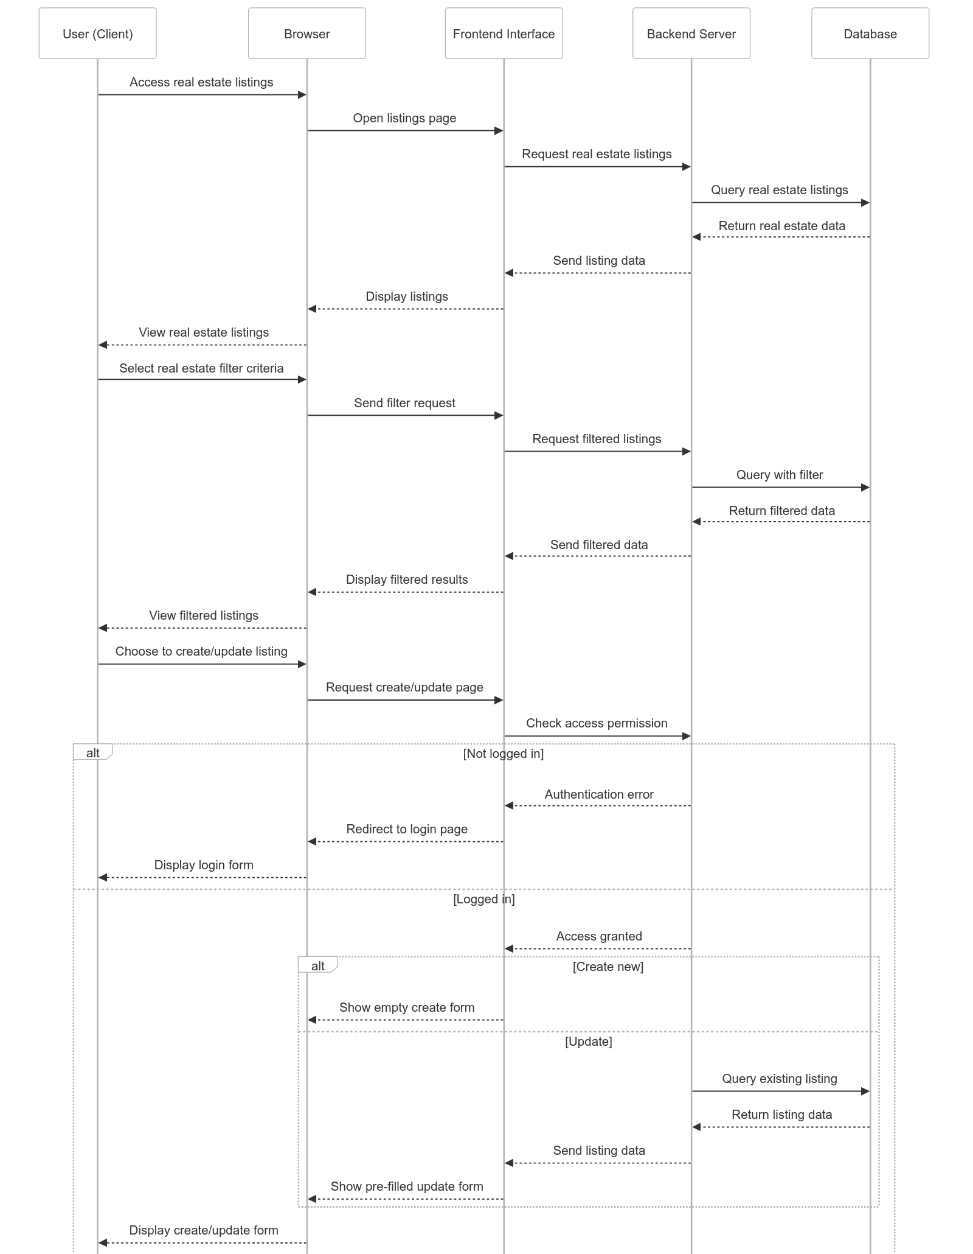

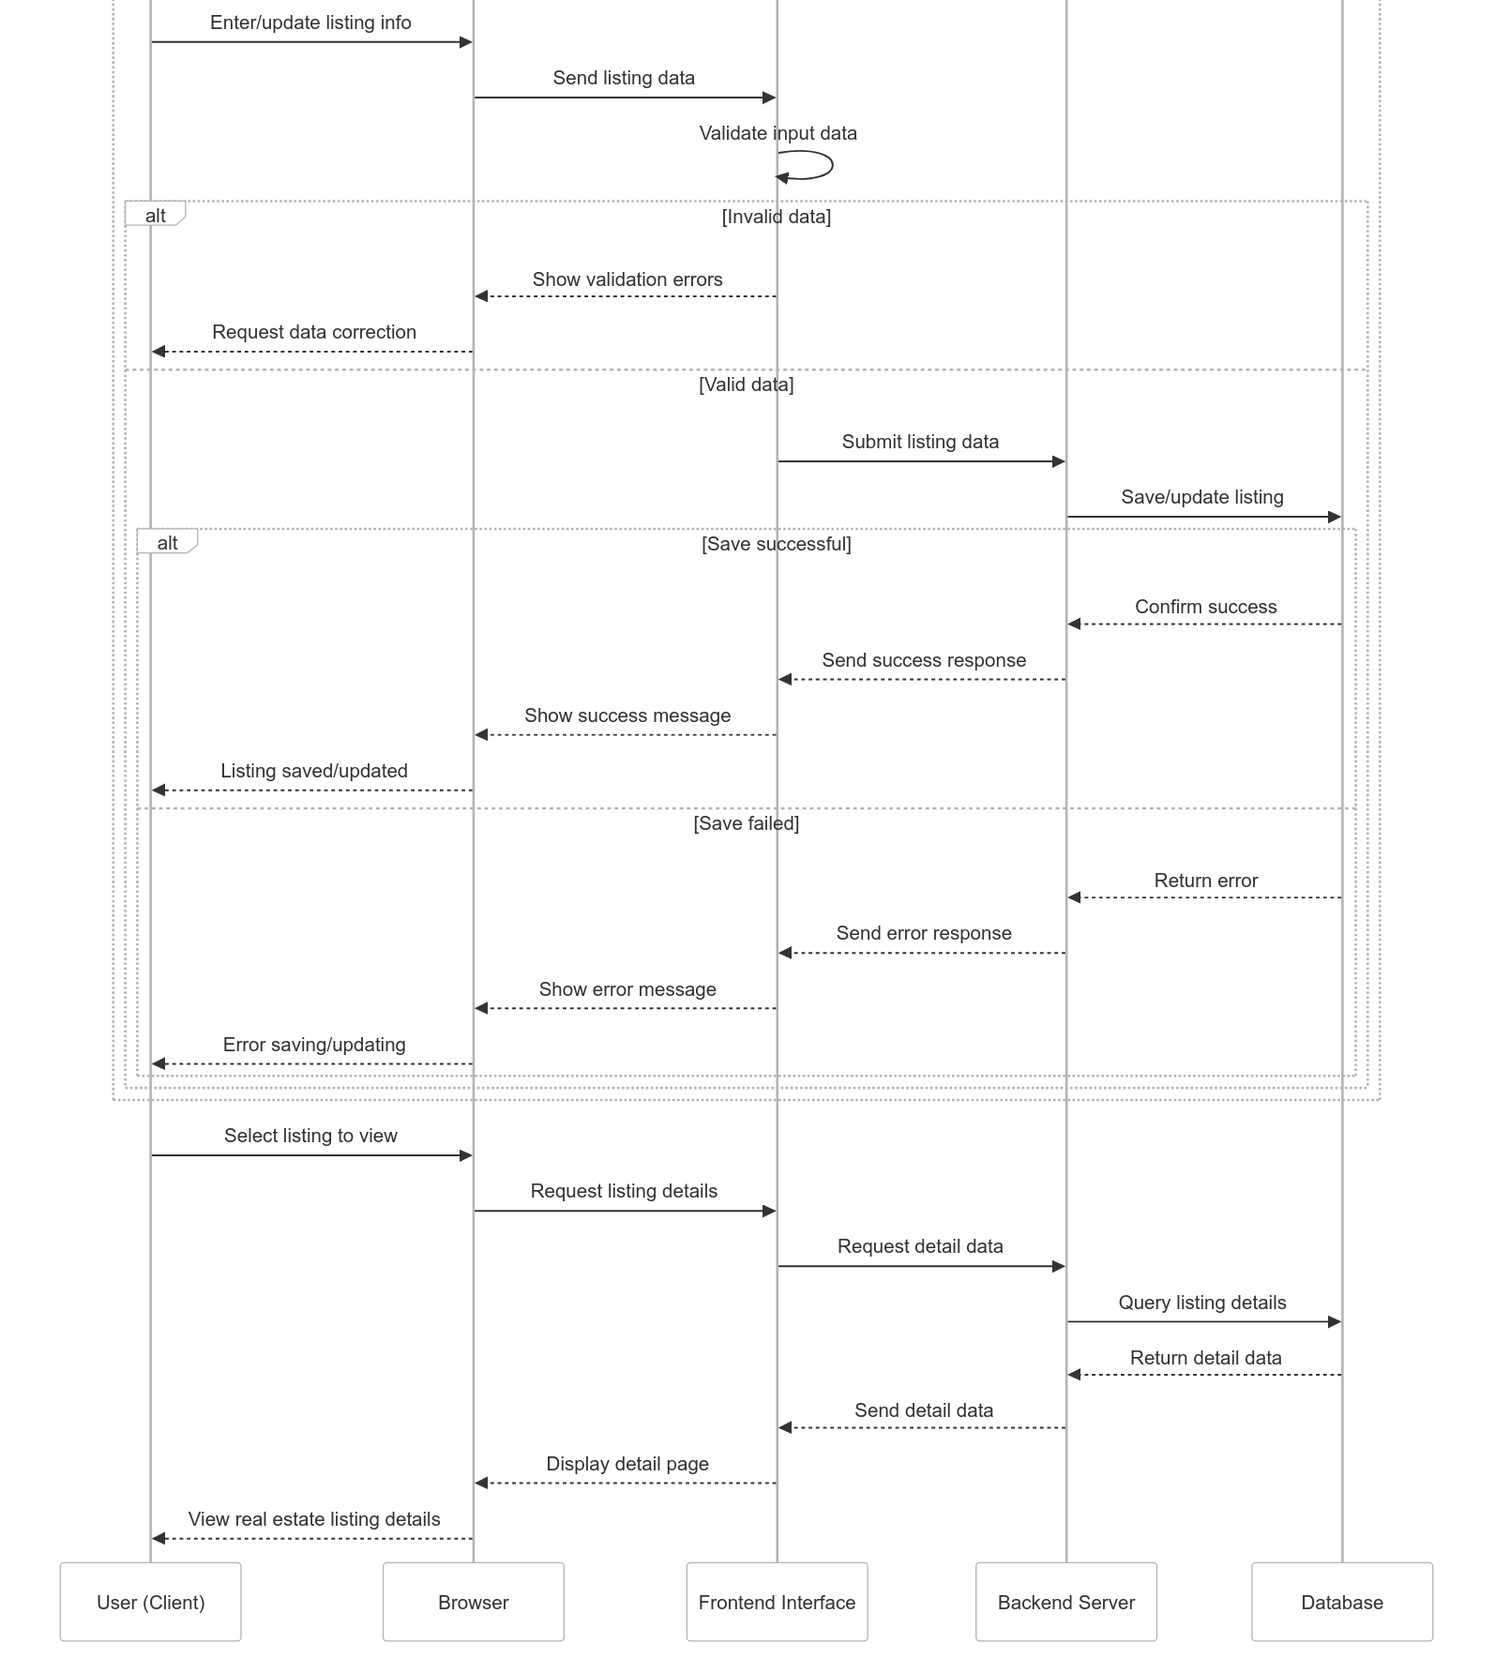

Figure . Real estate article management flow as a user

* Design of account upgrade flow, integrating online payment

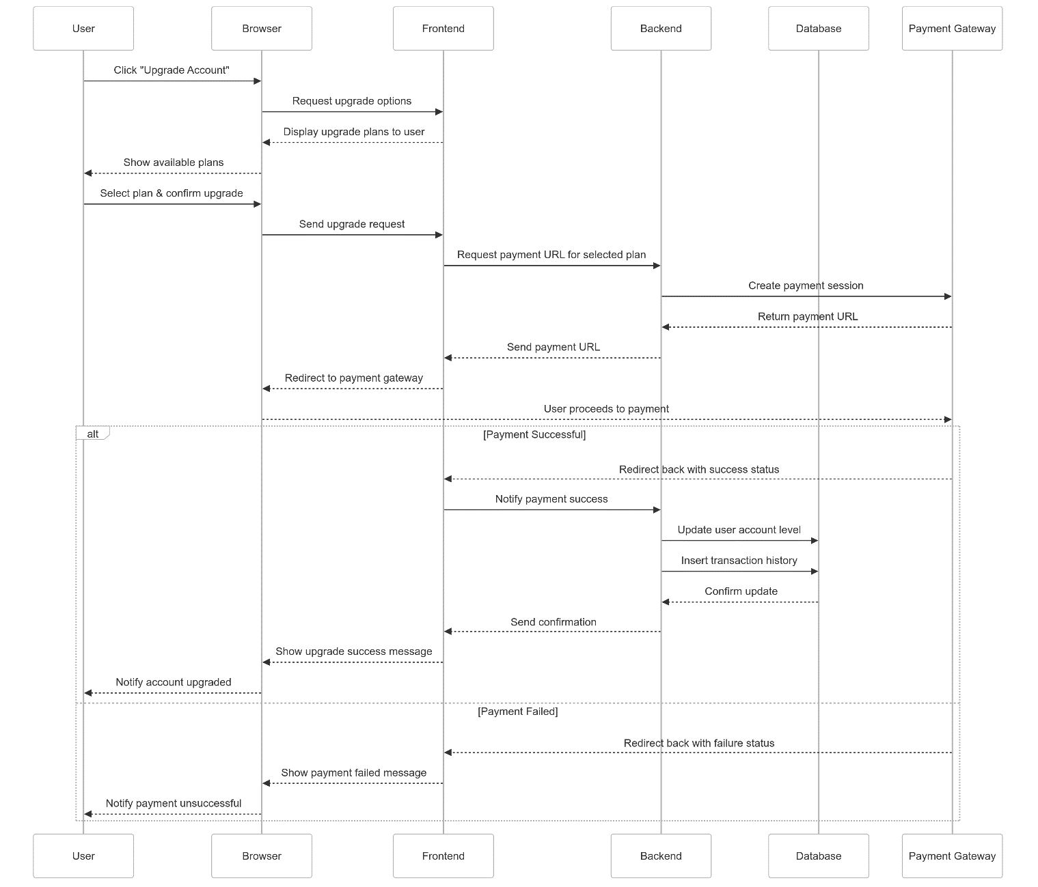

Figure . Account upgrade flow

## Database design

### ER (entity-relationship)

The ER entity relationship model is represented as

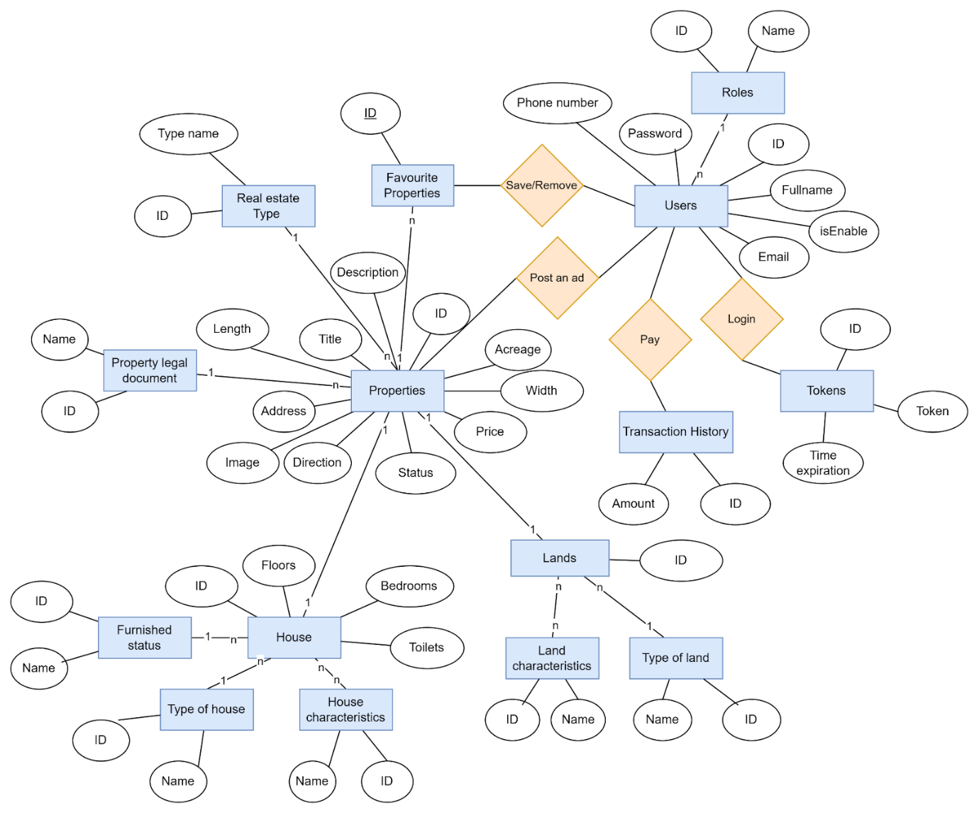

Figure . The ER entity relationship model

### Converting an implementation model into a system model

* Role table (roles)

Table . Describe role table attributes

|  |  |  |  |  |
| --- | --- | --- | --- | --- |
| Field Name | Data Type | Required | Constraint | Description |
| role_id | Integer | Not null | Primary Key | Code of permission |
| name | Enum | Not null |  | Name of permission |

* User table (users)

Table . Describe user table attributes

|  |  |  |  |  |
| --- | --- | --- | --- | --- |
| Field Name | Data Type | Required | Constraint | Description |
| user_id | Integer | Not null | Primary Key | Code of the user |
| role_id | Integer | Not null | Foreign Key | Permission |
| isEnable | Boolean | Not null |  | The user account is active or inactive |
| fullName | String | Not null |  | Full name of user |
| email | String | Not null |  | Email of user |
| password | String | Not null |  | Password of user(will be encrypted before entering the database) |
| phone | String | Not null |  | Phone number of user |
| created_at | LocalDataTime |  |  |  |
| updated_ad | LocalDataTime |  |  |  |

* Token table (tokens)

Table . Describe token table attributes

|  |  |  |  |  |
| --- | --- | --- | --- | --- |
| Field Name | Data Type | Required | Constraint | Description |
| token_id | Integer | Not null | Primary Key | Code of token |
| user_id | Integer | Not null | Foreign Key | User |
| token | String | Not null |  | A temporary or persistent string used to authenticate and authorize a user or system |
| created_at | LocalDataTime |  |  |  |
| updated_ad | LocalDataTime |  |  |  |

* Transaction history table

Table . Describe transaction histories table attributes

|  |  |  |  |  |
| --- | --- | --- | --- | --- |
| Field Name | Data Type | Required | Constraint | Description |
| transaction_id | Integer | Not null | Primary Key | Code of token |
| user_id | Integer | Not null | Foreign Key | User |
| amount | Number | Not null |  | Amount paid |
| created_at | LocalDataTime |  |  |  |
| updated_ad | LocalDataTime |  |  |  |

* Favourite property table (favourite_properties)

Table . Describe favourite properties of table attributes

|  |  |  |  |  |
| --- | --- | --- | --- | --- |
| Field Name | Data Type | Required | Constraint | Description |
| favourite_ property_id | Integer | Not null | Primary Key | Code of favourite property |
| user_id | Integer | Not null | Foreign Key | User |
| property_id | Integer | Not null | Foreign Key | Property |
| created_at | LocalDataTime |  |  |  |

* Category table (categories)

Table . Describe category table attributes

|  |  |  |  |  |
| --- | --- | --- | --- | --- |
| Field Name | Data Type | Required | Constraint | Description |
| category_id | Integer | Not null | Primary Key | Code of category |
| Name | String | Not null |  | Name of category |

* Property table (properties)

Table . Describe property table attributes

|  |  |  |  |  |
| --- | --- | --- | --- | --- |
| Field Name | Data Type | Required | Constraint | Description |
| property_id | Integer | Not null | Primary Key | Code of Property |
| user_id | Integer | Not null | Foreign Key | User |
| category_id | Integer | Not null | Foreign Key | Type of property |
| property_legal _document_id | Integer | Not null | Foreign Key | Type of property legal document |
| status | Enum | Not null |  | Approved or canceled |
| title | String | Not null |  | Title appears at the top of the article |
| description | String | Not null |  | Detailed description of the article |
| region | String | Not null |  | Province name |
| district_name | String | Not null |  | District name |
| ward_name | String | Not null |  | Ward name |
| street_name | String | Not null |  | Street name |
| longitude | Number | Not null |  | Coordinates |
| latitude | Number | Not null |  |
| direction | Number | Not null |  | Main direction of real estate |
| area | Number | Not null |  |  |
| length | Number | Not null |  |  |
| width | Number | Not null |  |  |
| images | String | Not null |  | Contains image links |
| price | Number | Not null |  |  |
| created_at | LocalDataTime |  |  |  |
| updated_ad | LocalDataTime |  |  |  |

* House table (houses)

Table . Describe house table attributes

|  |  |  |  |  |
| --- | --- | --- | --- | --- |
| Field Name | Data Type | Required | Constraint | Description |
| house_id | Integer | Not null | Primary Key | Code of house |
| property_id | Integer | Not null | Foreign Key | Code of property |
| furnished_ status_id | Integer | Not null | Foreign Key | Interior condition |
| house_ type_id | Integer | Not null | Foreign Key | Type of house |
| floors | Integer | Not null |  |  |
| bedrooms | Integer | Not null |  |  |
| toilets | Integer | Not null |  |  |

* Furnished status table (furnished_status)

Table . Describe furnished status table attributes

|  |  |  |  |  |
| --- | --- | --- | --- | --- |
| Field Name | Data Type | Required | Constraint | Description |
| furnished_ status_id | Integer | Not null | Primary Key | Code of furnished status |
| name | String | Not null |  | Describe the condition of the interior |

* Type of house table (house_type)

Table . Describe type of house table attributes

|  |  |  |  |  |
| --- | --- | --- | --- | --- |
| Field Name | Data Type | Required | Constraint | Description |
| house_ type_id | Integer | Not null | Primary Key | Code of house type |
| name | String | Not null |  | House type description |

* House characteristics table (house_characteristics)

Table . Describe house characteristics table attributes

|  |  |  |  |  |
| --- | --- | --- | --- | --- |
| Field Name | Data Type | Required | Constraint | Description |
| house_ characteristic_id | Integer | Not null | Primary Key | Code of house  characteristics |
| name | String | Not null |  | House characteristics description |

* + Here create an additional table (house_characteristic_mappings) to hold the characteristic keys of the house object.

Table . Describe house characteristic mapping table attributes

|  |  |  |  |  |
| --- | --- | --- | --- | --- |
| Field Name | Data Type | Required | Constraint | Description |
| house_characteristic_ mapping_id | Integer | Not null | Primary Key | Code of house  characteristic mapping |
| house_ characteristics_id | Integer | Not null | Foreign Key | House  characteristics |
| house_id | Integer | Not null | Foreign Key | House |

* Land table (lands)

Table . Describe land table attributes

|  |  |  |  |  |
| --- | --- | --- | --- | --- |
| Field Name | Data Type | Required | Constraint | Description |
| land_id | Integer | Not null | Primary Key | Code of house |
| property_id | Integer | Not null | Foreign Key | Code of property |
| land_type_id | Integer | Not null | Foreign Key | Type of land |

* Type of land table (land_types)

Table . Describe the type of land table attributes

|  |  |  |  |  |
| --- | --- | --- | --- | --- |
| Field Name | Data Type | Required | Constraint | Description |
| land_type_id | Integer | Not null | Primary Key | Code of land type |
| name | String | Not null |  | Land type description |

* Land characteristics table (land_characteristics)

Table . Describe land characteristics table attributes

|  |  |  |  |  |
| --- | --- | --- | --- | --- |
| Field Name | Data Type | Required | Constraint | Description |
| land _ characteristic_id | Integer | Not null | Primary Key | Code of land  characteristics |
| name | String | Not null |  | Land characteristics description |

* + Here, create an additional table (land_characteristic_mappings) to hold the characteristic keys of the land object.

Table . Describe land characteristic mapping table attributes

|  |  |  |  |  |
| --- | --- | --- | --- | --- |
| Field Name | Data Type | Required | Constraint | Description |
| land _characteristic_ mapping_id | Integer | Not null | Primary Key | Code of land  characteristic mapping |
| land _ characteristics_id | Integer | Not null | Foreign Key | Land  characteristics |
| house_id | Integer | Not null | Foreign Key | Land |

### Database schema

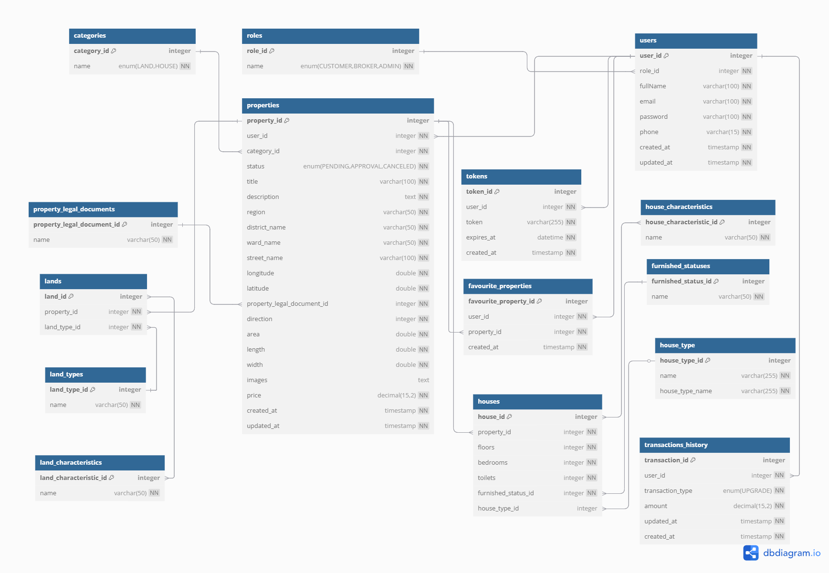

Figure . Relational Model

## Real estate prediction system development

* The problem of predicting real estate prices will be divided into two types:
  + Real estate valuation: Users will provide information related to the land or the house they want to sell or buy for the system to evaluate.
  + Real estate price forecast: The system will predict the price shortly after a certain area is given by users at the same level.
* Common processing steps of the two models

### Data crawling

* Collect data from the “Nhà tốt” website and have a “RawData.csv” file with 33270 samples.
  + This dataset contains two property types: house and land. For entries where the property type is land, the numerical values for **Rooms, Toilets, Floors and Furnishing Sell** are set to 0.

### Data cleaning

* Validate values: Check if there are any values less than 0

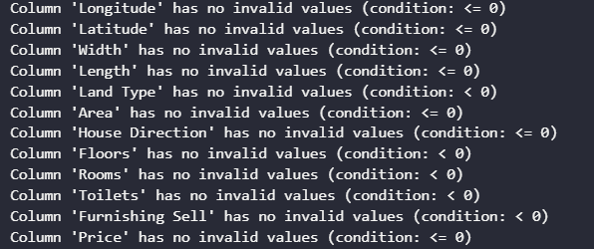

Figure . Statistics to check features with values less than 0

#### Handling missing

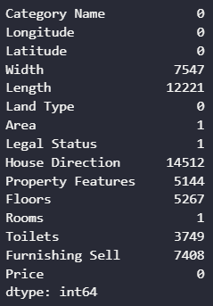

Figure . Statistics of missing values

* Since a large number of missing values can significantly alter the overall data distribution and characteristics when imputed, I decided to remove all samples with three or more missing features to preserve the integrity of the dataset.

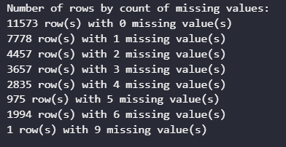

Figure . Distribution of rows based on the number of missing values

* Confirming that the area data is complete, we proceed to handle missing values for **width** and **length** as follows:
  + If either width or length is missing, we estimate the missing value using the area calculation formula (Area = Width × Length).
  + If both width and length are missing, we assign a default value of 5 meters for both width and length.

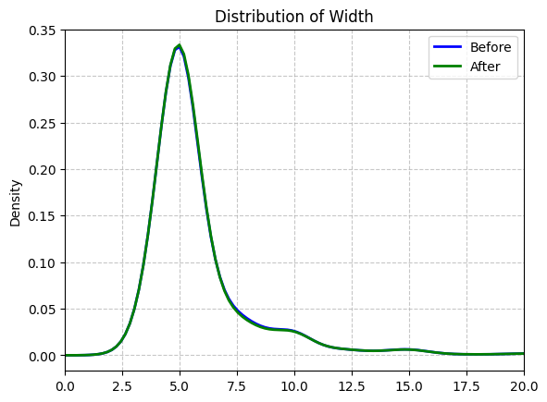

Figure . Width distribution before and after preprocessing

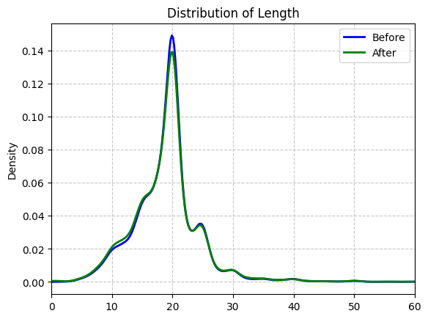

Figure . Length distribution before and after preprocessing

* For the **direction** feature, missing values are imputed using a random sampling method.

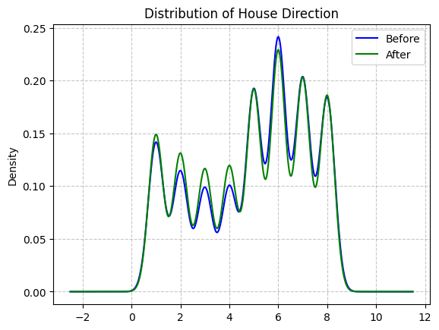

Figure . Direction distribution before and after preprocessing

* Regarding the **property features** variable:
  + If the land type is residential land, the default value for property features is set to 3 (partly residential land).
  + Otherwise, it is set to 2 (non-residential land).

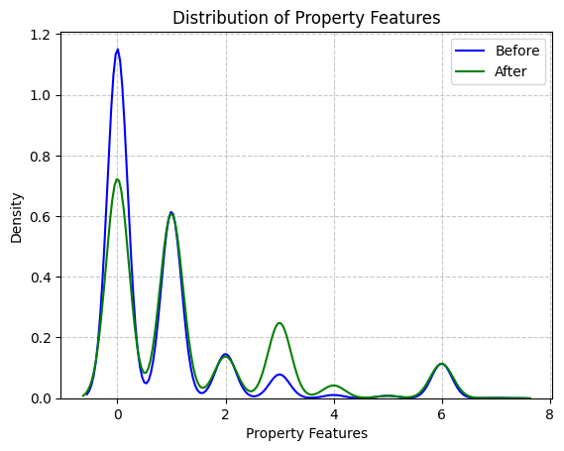

Figure . Property features distribution before and after preprocessing

* As for the **floor features**, based on common housing layouts:
  + The ground floor typically contains 1 bedroom.
  + Each upper floor usually has 2 bedrooms.

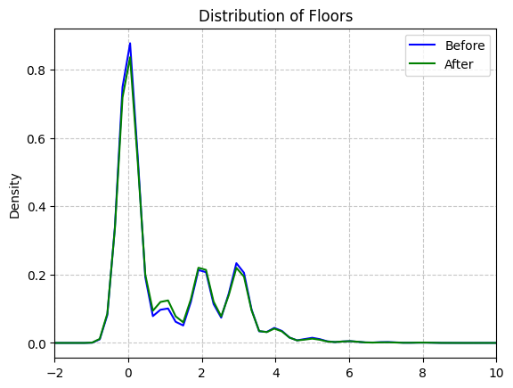

Figure . Floor distribution before and after preprocessing

* The number of **toilets** is assumed to be equal to the number of floors.

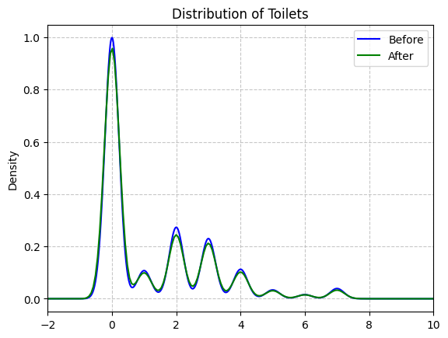

Figure . Toilet distribution before and after preprocessing

* Finally, for the **furnishing sell** feature, missing values are also imputed using a random sampling method.

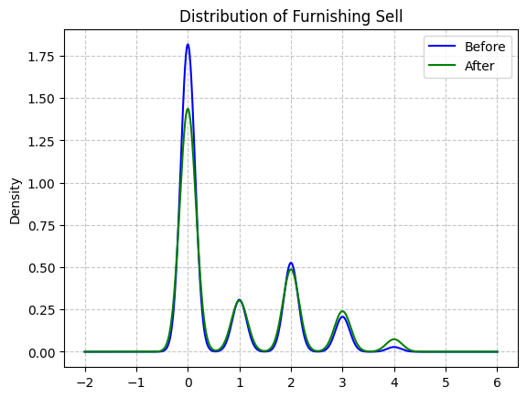

Figure . Furnishing sales distribution before and after preprocessing

***Notes****: Most plots show that data cleaning preserved the original distribution shape, indicating that the overall data structure remained largely intact. In the “Distribution of Length” and “Distribution of Width” plots, cleaning effectively removed some outliers in the right tail. Key distribution peaks were maintained across most features, suggesting minimal impact on the core data.*

*However, in the “Distribution of Property Features” plot, there is a noticeable difference between the before (blue) and after (green) curves, especially in the 0–1 range, which may indicate a loss of important information. Similarly, in the “Distribution of Furnishing Sell” plot, the main peak’s density decreased after cleaning, potentially affecting analyses involving this feature.*

#### Handling outliers

* These charts reveal several serious issues with the data distribution, as most variables are heavily skewed and concentrated within a very narrow range of values.

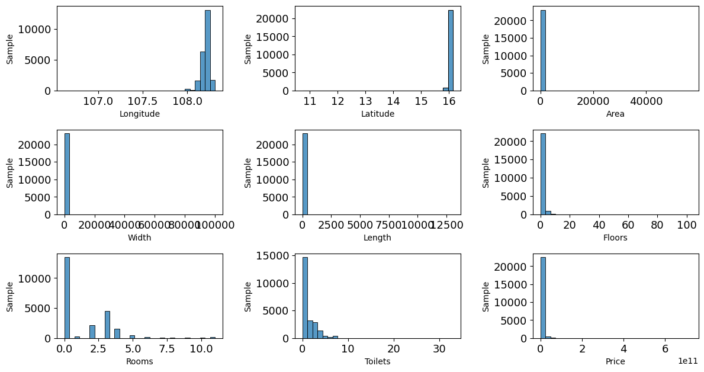

Figure . Histogram plots of feature distributions

* To improve data quality, we applied outlier removal techniques to variables with high skewness. This helped reduce the impact of extreme values and enhanced the reliability of subsequent analyses and modeling

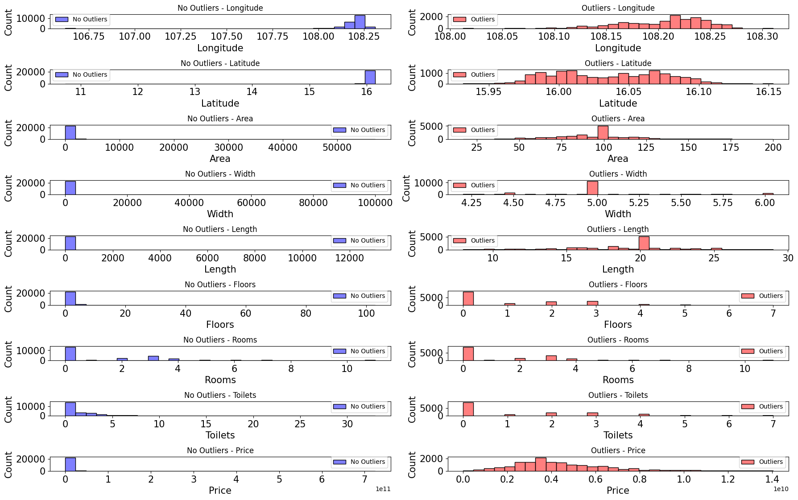

Figure . Visual comparison of outlier impact on feature distributions

* The process returns a cleaned dataset containing the following fields and is exported as “Cleandata.csv”:
  + Real estate valuation:

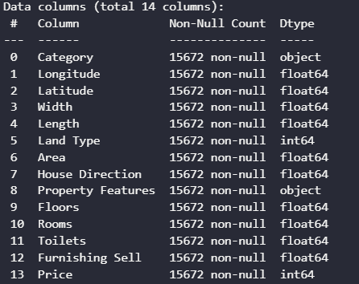

Figure 2.25 Real estate valuation model features

* + Real estate price forecast:

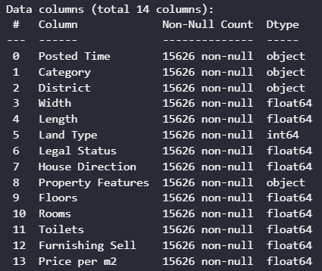

Figure 2.26 Real estate price forecast features

* The two problems use slightly different features. For the valuation model, exact coordinates are included since price can vary significantly even along the same street. For the forecasting model, time becomes a crucial factor and detailed coordinate data is sparse. Therefore, we generalize location by district and use **price per m²** as the target variable.

### **Feature Engineering**

* Feature Transformation:
  + First, one-hot encoding is applied to categorical variables such as **property category, land type, direction, furnishing status and district.**
  + For numerical features, various normalization techniques (e.g., Z-score, log, sqrt, min-max, arsinh) are tested. The most effective method is selected based on distribution analysis.
  + The result is a transformed dataset exported as “TransformedData.csv”.

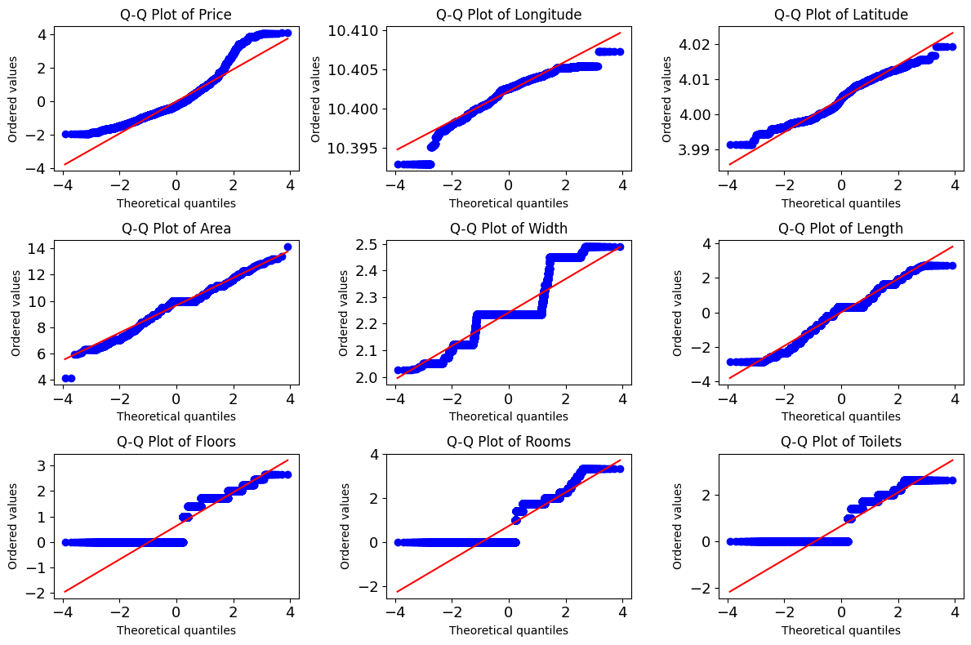

Figure . Q-Q Plots after optimal normalization per feature

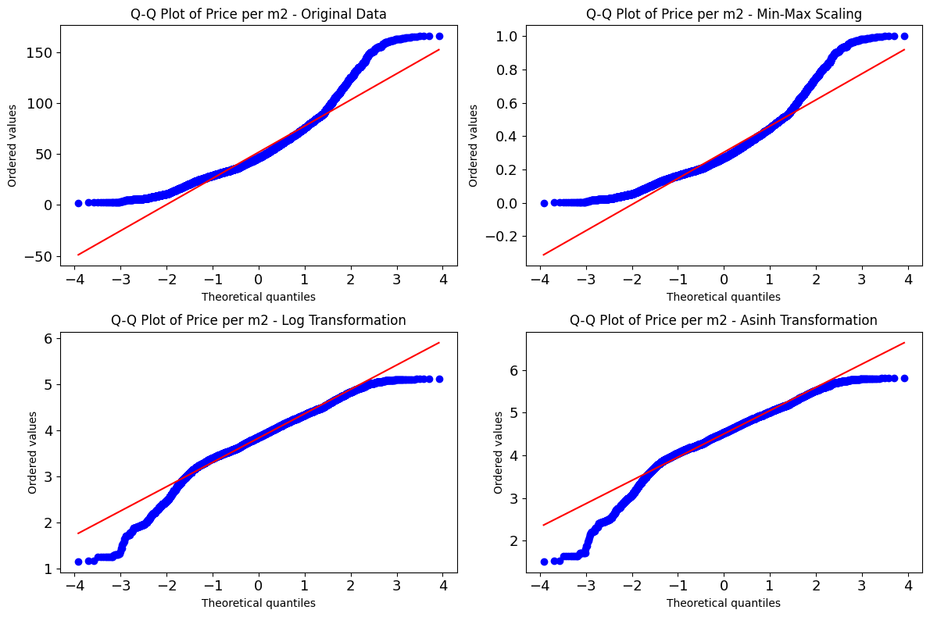

Figure . Comparison of Q-Q Plots of **Price per m²** across different transformation methods

* Feature Selection:
  + Observing the relationships between the coordinates (Longitude, Latitude), area and width with the target variable (Price), it was noted that these features have a slight correlation with the target.

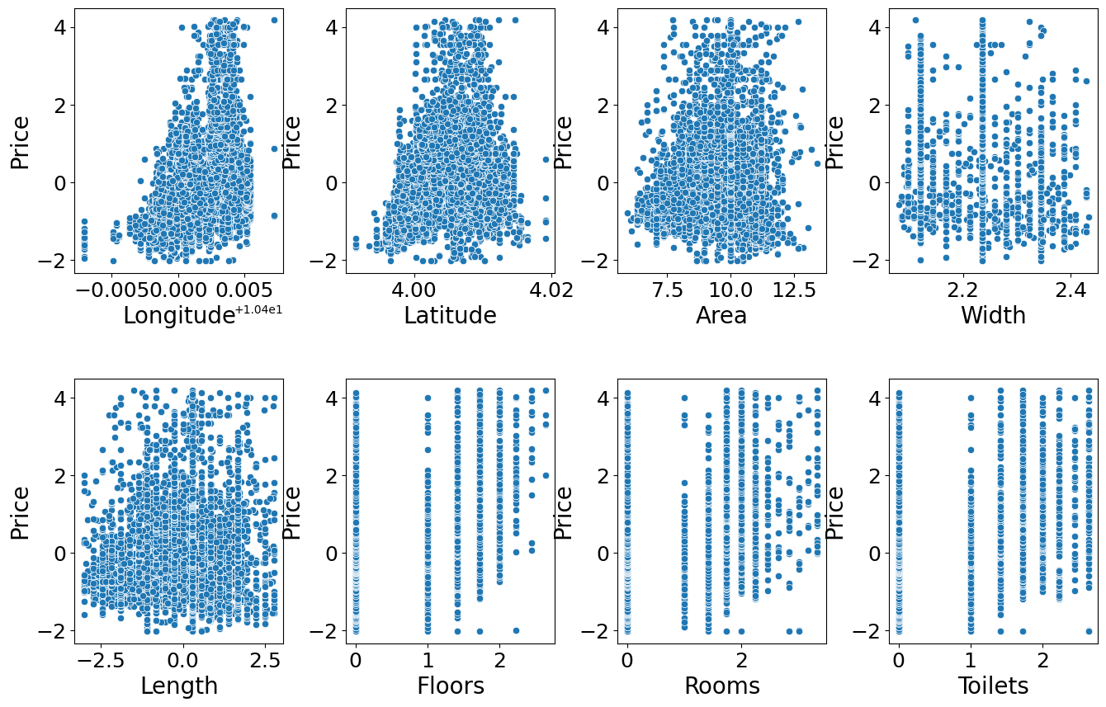

Figure . Scatter plot of features vs. **Price**

* + **SelectKBest** was used to rank the features based on their correlation with the target, with **Longitude** and **Latitude** being the most influential.

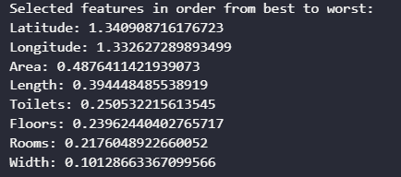

Figure . Selected features in order from best to worst.

* + The **RFECV** method was then applied, selecting the optimal number of features, which is 8 in this case. The best set of features for predicting the target variable includes **Longitude, Latitude, Area, Width, Length, Floors, Rooms and Toilets**.

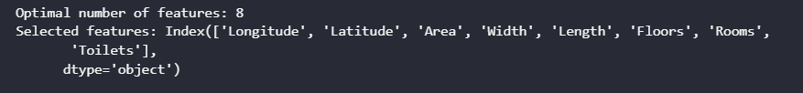

Figure . Optimal number of features

* + The plot of the **RFECV** shows the relationship between the number of selected features and the mean test accuracy.

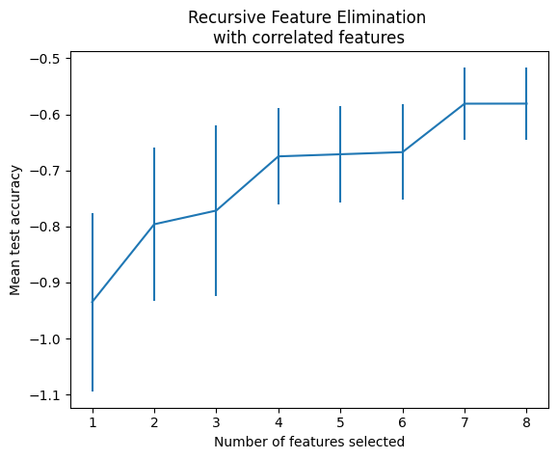

Figure . Recursive Feature Elimination with correlated features

### Real estate valuation model

* The dataset is divided into two parts:
  + 80% for training (11151 samples)
  + 20% for testing (2788 samples)
* Three regression algorithms are applied to build the models: Linear Regression, Ridge Regression and Random Forest Regression.
* The evaluation metrics for the Random Forest Regression model that achieved the best performance are presented below:

Table . Evaluation metrics table for the real estate valuation models

|  |  |  |
| --- | --- | --- |
|  | Train set | Test set |
| MSE | 0.1689 | 0.2379 |
| RMSE | 0.4109 | 0.4876 |
| R-Squared | 82.82% | 77.75% |

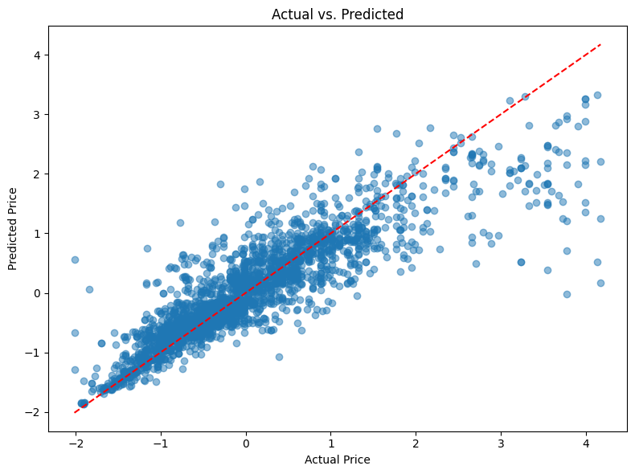

Figure . Scatter plot of actual vs. predicted real estate prices on the test set

### Real estate price forecast model

* To handle time-based patterns, we extracted temporal features from the **Posted Time** field:
* **year, month, day, day of week and quarter**: These features are kept to retain temporal information, helping the model better understand when each data point occurred.
* The dataset was split into two parts:
  + 80% for training (11151 samples)
  + 20% for testing (2788 samples)
* Three forecasting models were applied for comparison: XGBoost Regressor, LightGBM Regressor, Facebook Prophet, Ridge Regression and Random Forest Regression.
* The evaluation metrics for the Random Forest Regression model that achieved the best performance is presented below:

Table . Evaluation metrics table for the real estate price forecast models

|  |  |  |
| --- | --- | --- |
|  | Train set | Test set |
| MSE | 0.024 | 0.0769 |
| RMSE | 0.1548 | 0.2772 |
| R-Squared | 91.75% | 73.87% |

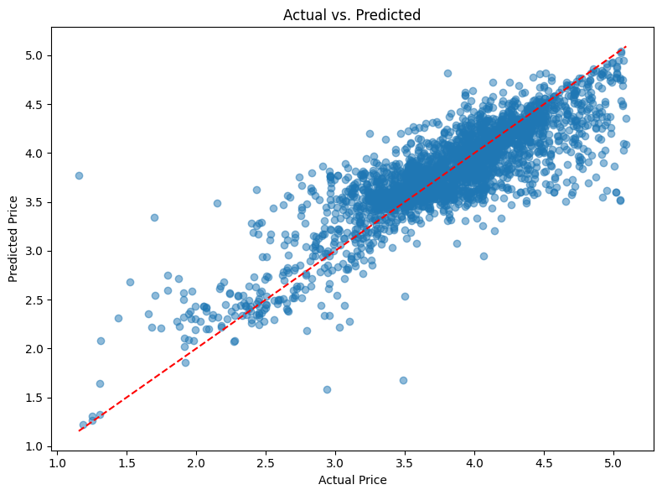

Figure . Scatter plot of actual vs. predicted real estate prices per m2 on the test set

## Apply NSFW image and toxic content classification models

### NSFW image classification models

In this project, I integrated the NudeNetv2 model to detect and classify sexually explicit content in images. I utilized the pre-trained “classifier_model.onnx” for efficient inference.

The model categorizes content into two classes:

* safe – The image/video is not sexually explicit
* unsafe – The image/video contains nudity or explicit content

I cloned the repository and used the available ONNX version of the classifier to perform predictions on image data.

This classification component plays a crucial role in automatically filtering out inappropriate content, enhancing the safety and compliance of our platform.

## Chapter conclusion

This chapter provides the reader with an overview of the real estate business operations, offering insights into the key activities and processes involved in the industry. It also includes an analysis and design of the system architecture, along with a detailed discussion of the database model. Additionally, the chapter focuses on the development of a price support system, which aims to assist buyers by offering pricing assistance and making real estate transactions more accessible.

# IMPLEMENTATION AND RESULTS EVALUATION

## Description of achieved functionalities

### Customer-facing functionality

* **Log in**

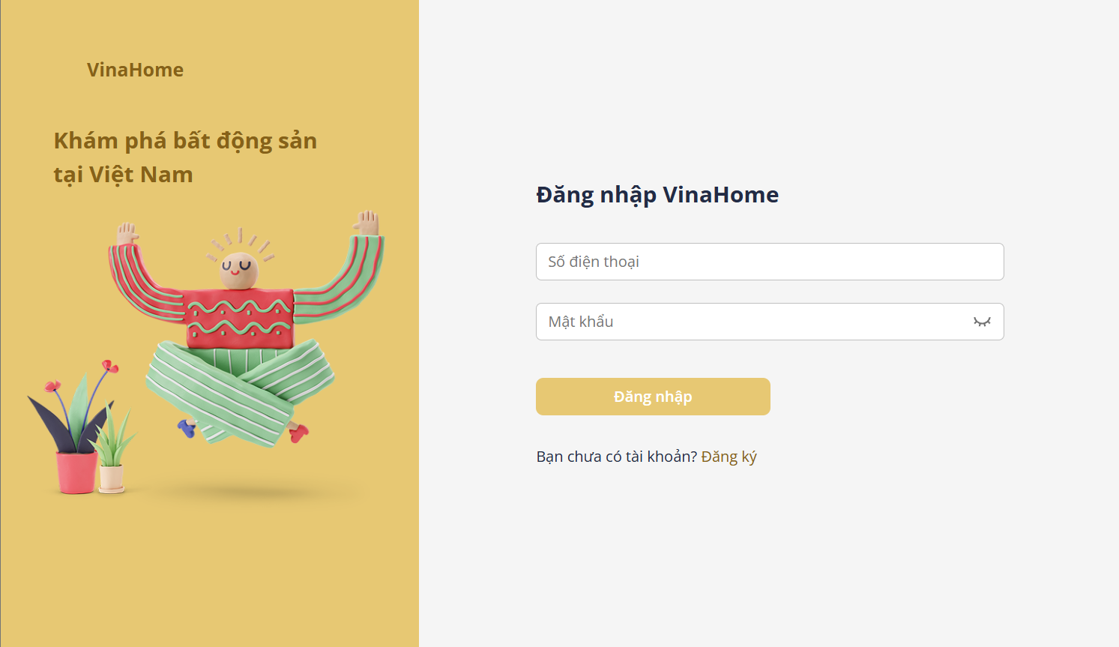

Figure . Login interface

* + The system provides a login page for users to enter their phone number and password. The system will verify the entered credentials against the system's user database.
  + If the account is not found in the system or is found but the password does not match, the system will display an error message to the user.
  + If the login is successful, the system will check the assigned role and redirect the user to the main screen of the application.

Table . Login function specification

|  |  |  |  |
| --- | --- | --- | --- |
| **Interface** | Login | | |
| **Description** | Displays the login page | | |
| **Access** | Users click the “Đăng nhập” button located on the header to access the login page. | | |
| Interface Contents | | | |
| **Item** | **Type** | **Description** | |
| Số điên thoại | Input | Enter phone number | |
| Mật khẩu | Input | Enter account password | |
| Đăng nhập | Button | Log in and access the website | |
| Đăng ký | Button | Register if the user has no account | |
| **Actions** | | | |
| **Name** | **Description** | **Success** | **Failure** |
| Log in | User enters phone number and password | Check user role; if the role is Customer or Broker, redirect to the homepage; if the role is Admin, redirect to the management page. | Invalid username will display the message “Tài khoản không tồn tại”. Wrong password will display the message “Số điện thoại hoặc mật khẩu không đúng”. Locked account will display the message “Tài khoản của bạn đã bị khoá”. |
| Register | Create a new account if the user doesn't have one | Display the account registration page | Do not redirect to a new page. |

* **Sign up**

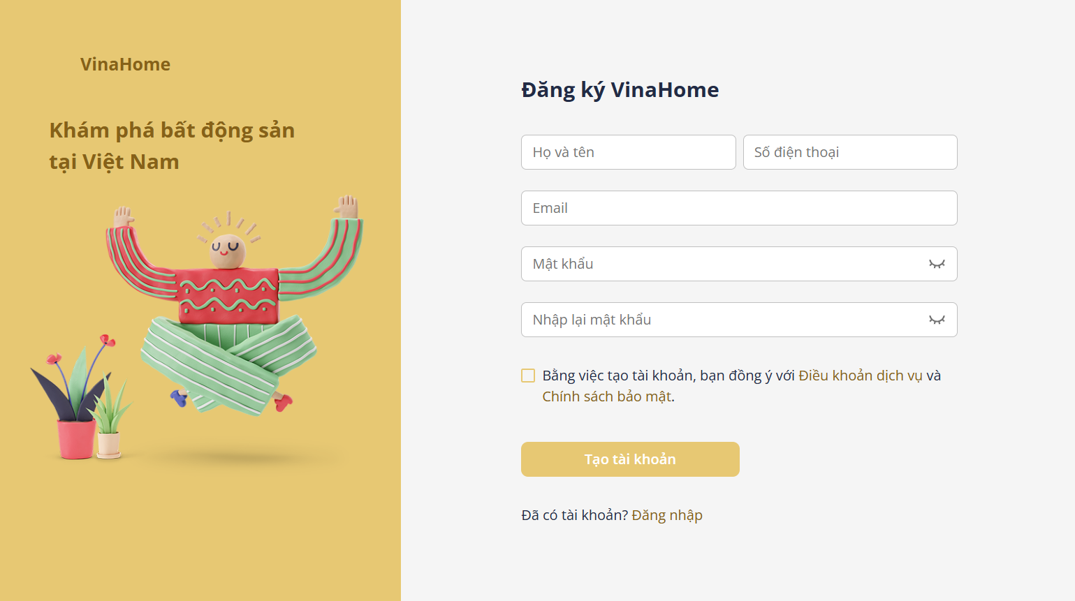

Figure . Register interface

* + When a user needs to log in but doesn't have an account, they will proceed to register for one.

Table . Register function specification

|  |  |  |  |
| --- | --- | --- | --- |
| **Interface** | Register | | |
| **Description** | Displays the register page | | |
| **Access** | The user accesses the login page and clicks the “Đăng ký” button. | | |
| Interface Contents | | | |
| **Item** | **Type** | **Description** | |
| Họ và tên | Input | Enter full name | |
| Số điên thoại | Input | Enter phone number | |
| Mật khẩu | Input | Enter account password | |
| Nhập lại mật khẩu | Input | Enter the account password again | |
| Đăng ký | Button | Register account | |
| Đồng ý với điều khoản | Checkbox | By creating an account, user agree to the terms of service and privacy policy. | |
| Đăng nhập | Button | Log in if the user has an account | |
| **Actions** | | | |
| **Name** | **Description** | **Success** | **Failure** |
| Đăng ký | The user enters personal information | The system redirects users to the login page and the data is stored in the database. | If any required information is missing or incorrectly formatted, a warning message is displayed.  If the re-entered password does not match the original password, a warning message is shown.  If the phone number or email already exists, the message “Số điện thoại/Email đã tồn tại” is displayed. |
| Đăng nhập | Log in if the user has one | Display the login page | Do not redirect to a new page. |

* **Post list**

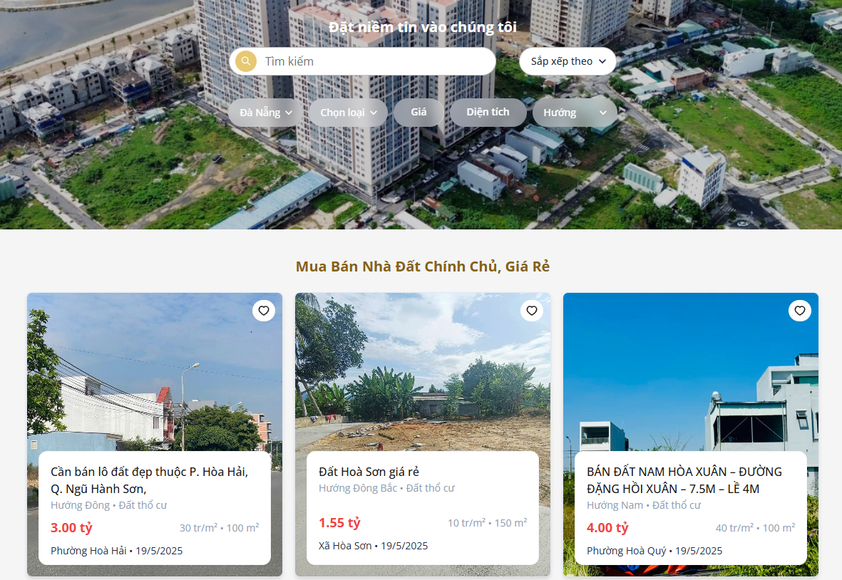

Figure . Post list interface

* + When a property type is selected, the filtering criteria are dynamically adjusted to match the characteristics of the chosen property category.

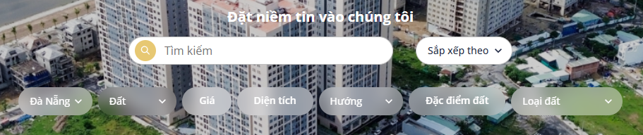

Figure . Search filter interface when selecting “Land” as the property type

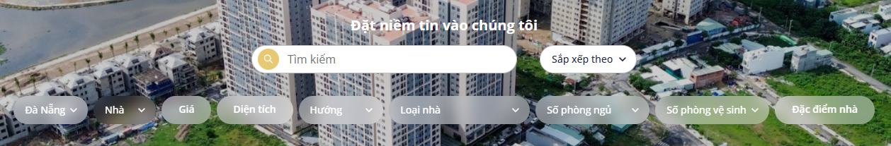

Figure . Search filter interface when selecting “House” as the property type

Table . Function specifications for the post list

|  |  |  |  |
| --- | --- | --- | --- |
| **Interface** | Property post list | | |
| **Description** | Displays the interface that shows property listings with search and filter functionality. | | |
| **Access** | The user selects “Bài đăng” in the header or applies any filter criteria to refine the property listings. | | |
| Interface Contents | | | |
| **Item** | **Type** | **Description** | |
| Tìm kiếm | Input | Search bar for property listings by title and description. | |
| Sắp xếp theo | Selectbox | Sort listings by different criteria | |
| Chọn loại | Selectbox | Select property category (land, house) | |
| Chọn tỉnh/thành | Selectbox | Select province/city | |
| Giá | RangeInput | Select the minimum and maximum price values. | |
| Diện tích | RangeInput | Select the minimum and maximum area in square meters. | |
| Hướng | Selectbox | Select property orientation | |
| Loại hình đất | Selectbox | Select land type | |
| Đặc điểm đất | RadioCheckbox | Select land characteristics | |
| Số phòng ngủ | Selectbox | Select the number of bedrooms | |
| Số phòng vệ sinh | Selectbox | Select the number of bathrooms | |
| Loại nhà | Selectbox | Select house type | |
| Đặc điểm nhà | RadioCheckbox | Select house characteristics | |
| Save post icon | Button | Save or remove a favourite post | |
| **Actions** | | | |
| **Name** | **Description** | **Success** | **Failure** |
| Apply filters | Enter keyword, select one or more filters. | Show listings matching the selected filters. | Display message: “ Không tìm thấy bất động sản nào”. |
| View property details | Click a property listing card. | Redirect to the detail page showing full information. | Show message “Không tìm thấy bất động sản” if details cannot be loaded. |
| Save to favorites | Click heart icon on a listing | Listing added to favorites; heart icon turns red. | If the user is not logged in, the system shows “Vui lòng đăng nhập để lưu bài viết”. |

|  |
| --- |
|  |

* **Post details**

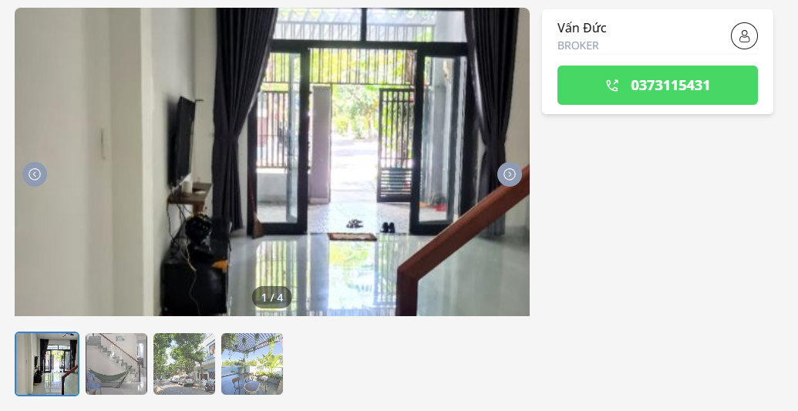

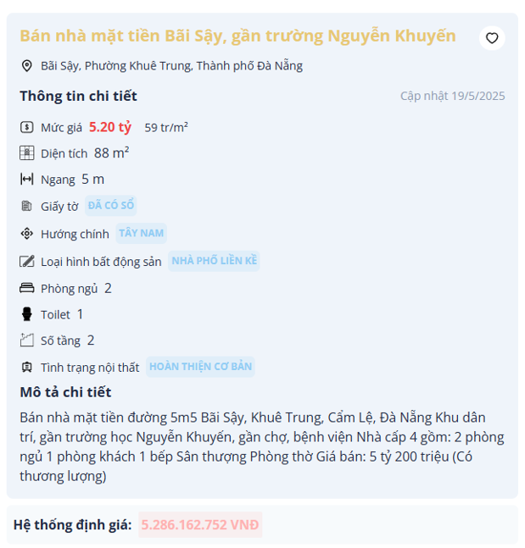

Figure . The post detail interface

* + This page displays detailed information about the property. The system also uses machine learning to estimate the property's value based on its characteristics.

Table . Function specifications for the post detail

|  |  |  |  |
| --- | --- | --- | --- |
| **Interface** | Detail real estate post | | |
| **Description** | Displays the interface that shows property listings with search and filter functionality. | | |
| **Access** | The user selects property card in the post list or personal favourite post list | | |
| Interface Contents | | | |
| **Item** | **Type** | **Description** | |
| Arrow icons | Button | View the next or previous image | |
| Heart icon | Button | Add or remove from the favorites list | |
| Định giá | Button | Evaluate real estate price | |
| **Actions** | | | |
| **Name** | **Description** | **Success** | **Failure** |
| View next/previous image | The user clicks the left or right arrow icon to view other images in the gallery. | The system displays the previous or next image smoothly | If the image cannot be loaded, the system displays an error placeholder |
| Add/remove favorite | The user clicks the heart icon to add or remove the property from favorites. | If logged in, the heart icon toggles and the listing is added/removed from favorites | If the user is not logged in, the system shows “Vui lòng đăng nhập để lưu bài viết”. |
| Evaluate the property | The user clicks the "Định giá" button to estimate the property value using ML. | The system returns an estimated price based on property features | If the evaluation fails, the system displays “Hệ thống định giá thất bại” |

|  |
| --- |
|  |

* **Favorite posts**

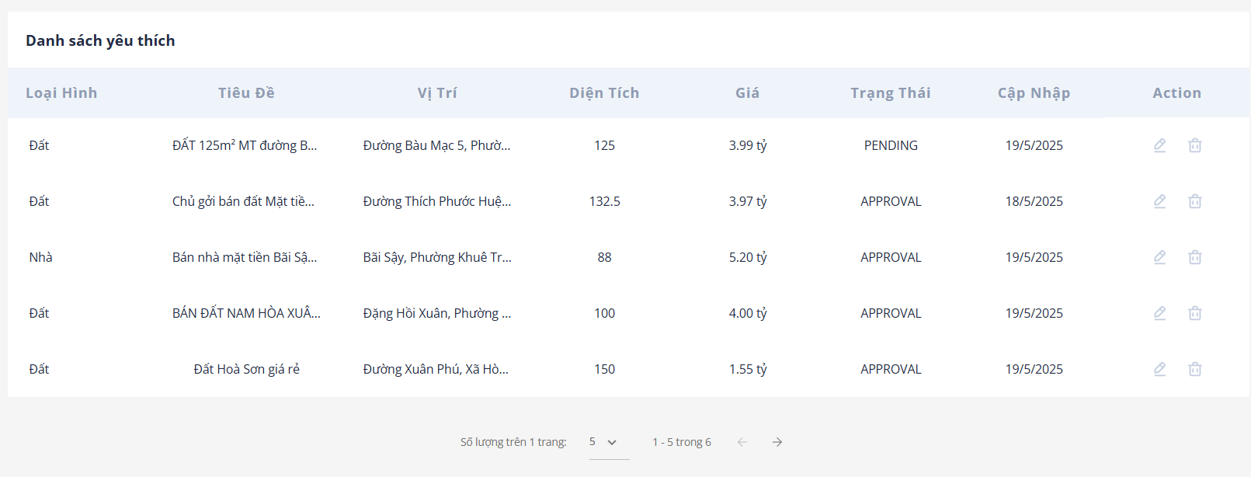

Figure . The love post detail interface

* + This page displays the list of posts the user has saved. When deleting a post, a confirmation warning message will appear.

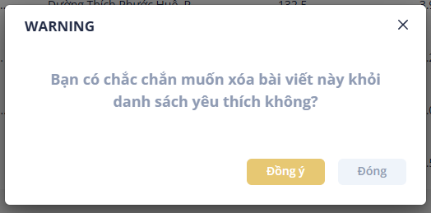

Figure . Favorite post deletion confirmation popup

Table . Function specifications for the favourite post list

|  |  |  |  |
| --- | --- | --- | --- |
| **Interface** | The favourite post list | | |
| **Description** | Displays the interface that shows the favourite post list | | |
| **Access** | The user selects “Bài viết đã lưu” from the user menu in the header. | | |
| Interface Contents | | | |
| **Item** | **Type** | **Description** | |
| |  | | --- | | Bin icon | | Button | Remove the property from the favorite post list. | |
| |  | | --- | |  | | Pen icon | | | Button | Show detailed post | |
| **Actions** | | | |
| **Name** | **Description** | **Success** | **Failure** |
| View post details | The user clicks the pen icon to open the detailed view of a saved property listing | The system redirects to the post detail page | Show message “Không tìm thấy bài viết” if details cannot be loaded |
| Remove from favorites | The user clicks the bin icon, a confirmation message is shown and click “Đồng ý” button to remove | The property is removed from the list | The system displays “Xoá bài viết yêu thích thất bại” if the removal fails |

* **Add a new post**
  + To sell a property, user visit the posting page and select the type of property they wish to sell.



Figure . Property type select box

* + The system will then display input fields corresponding to the property type chosen by the user.

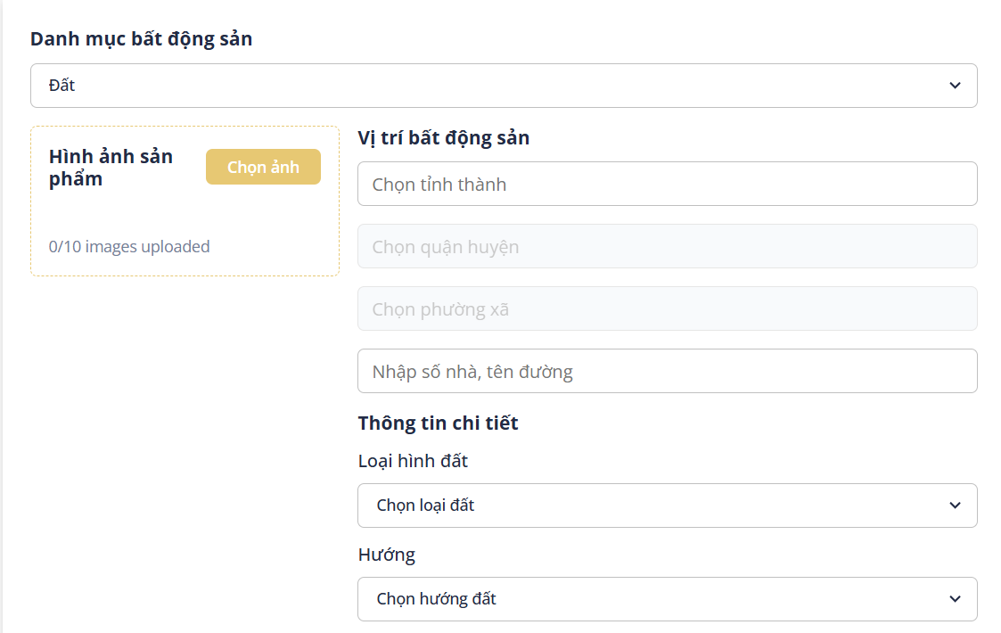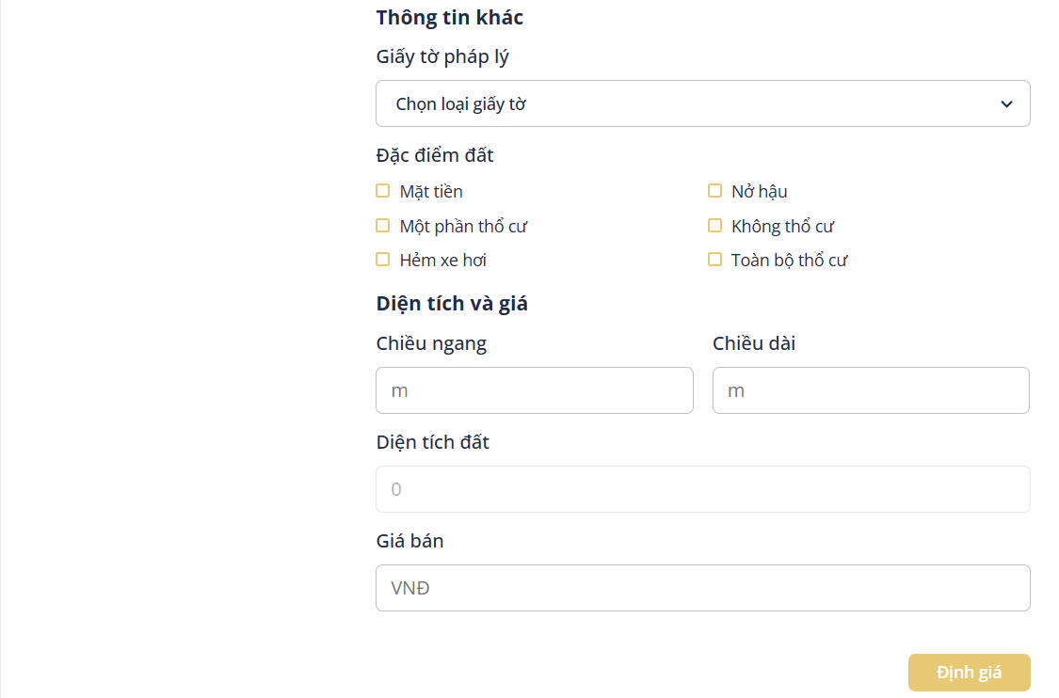

Figure . Add new post interface

Table . Add new post function specification

|  |  |  |  |
| --- | --- | --- | --- |
| **Interface** | Add property post | | |
| **Description** | Displays the interface that allows users to add new property information to the system. | | |
| **Access** | The user logs into the system and selects the “Đăng tin” in the header | | |
| Interface Contents | | | |
| **Item** | **Type** | **Description** | |
| Danh mục bất động sản | Selectbox | Select property category (land, house) | |
| Chọn tỉnh/thành | Selectbox | Select province/city | |
| Chọn quận/huyện | Selectbox | Select district | |
| Chọn xã/phường | Selectbox | Select ward | |
| Nhập số nhà, tên đường | Input | Enter the house number and street name | |
| Loại hình đất | Selectbox | Select land type | |
| Hướng | Selectbox | Select property orientation | |
| Giấy tờ pháp lý | Selectbox | Select legal document type | |
| Đặc điểm đất | RadioCheckbox | Select land | |
| Số tầng | Input | Enter the number of floors | |
| Số phòng ngủ | Selectbox | Select the number of bedrooms | |
| Số phòng vệ sinh | Selectbox | Select the number of bathrooms | |
| Tình trạng nội thất | Selectbox | Select the property's interior status | |
| Loại nhà | Selectbox | Select house type | |
| Đặc điểm nhà | RadioCheckbox | Select house characteristics | |
| Giá bán | Input | Enter the property selling price | |
| Tiêu đề tin đăng | Input | Enter post title | |
| Mô tả chi tiết | Textarea | Enter a detailed property description | |
| Định giá | Button | Button to evaluate the property | |
| Đăng tin | Button | Button to upload a post | |
| Hình ảnh bất động sản | Button | Button to upload property images | |
| **Actions** | | | |
| **Name** | **Description** | **Success** | **Failure** |
| Upload images | The user selects and uploads property images | The system displays uploaded images, counts the number of images. | If any image is detected to contain sensitive content, a warning message “Hình ảnh có chứa nội dung nhạy cảm” will be displayed and the post will be blocked from being submitted.  If the number of uploaded images exceeds the allowed limit, the system displays the message “Số lượng ảnh không vượt quá 10” |
| Evaluate property | The user fills in the required information and clicks the “Định giá” button | The system returns an estimated value based on the information provided. | If any required fields are missing or contain invalid data, the system displays appropriate error messages. |
| Upload post | The user completes the required information and clicks the “Đăng tin” button. | The system saves the property details to the database and redirects the user to the post listing page. The newly submitted post is marked with a “**Pending**” status. | If required fields are missing or invalid, the system shows relevant error messages.  If fewer than 3 images are uploaded, the system displays the message “Vui lòng tải lên ít nhất 3 hình ảnh”.  If the user has reached the maximum number of allowed listings (3 listings for regular users, 30 listings for brokers), the system displays “Tài khoản này đã đạt tối đa số lượng bài viết bất động sản.” |

* **Personal information**



Figure . Profile information interface

Table . Update profile function specification

|  |  |  |  |
| --- | --- | --- | --- |
| **Interface** | Profile information | | |
| **Description** | Displays the interface that shows personal information | | |
| **Access** | The user selects “Thông tin cá nhân” from the user menu in the header | | |
| Interface Contents | | | |
| **Item** | **Type** | **Description** | |
| Họ và tên | Input | Enter full name | |
| |  | | --- | |  |   Email | Input | Enter email | |
| Số điện thoại | Input | Enter phone number | |
| Lưu thay đổi | Button | Save the updated information | |
| **Actions** | | | |
| **Name** | **Description** | **Success** | **Failure** |
| Update profile | The user updates one or more fields and clicks “Lưu thay đổi” | The system saves the new information and shows a message “Cập nhập thông tin thành công” | The system displays "Cập nhật thông tin thất bại" if saving fails |

* **My posts**

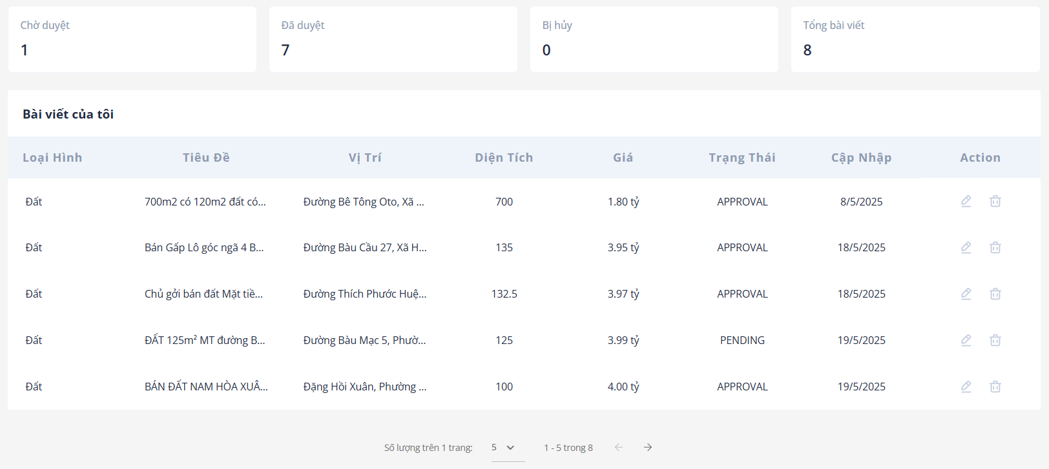

Figure . Personal post list interface

* + This page displays statistics of the posts published by the user. When the user attempts to delete a post, a confirmation warning message is shown.



Figure . Personal post deletion confirmation popup

Table . Function specifications for the personal post list

|  |  |  |  |
| --- | --- | --- | --- |
| **Interface** | The favourite post list | | |
| **Description** | Displays the interface that shows a list of personal posts | | |
| **Access** | The user selects “Bài viết của tôi” from the user menu in the header | | |
| Interface Contents | | | |
| **Item** | **Type** | **Description** | |
| |  | | --- | | Bin icon | | Button | Remove the property from the post list. | |
| |  | | --- | |  | | Pen icon | | | Button | Update the post information. | |
| **Actions** | | | |
| **Name** | **Description** | **Success** | **Failure** |
| Update post details | The user clicks the pen icon to open the edit view of a posted property | The system redirects to the property post editing page. | Show message “Không tìm thấy bài viết” if details cannot be loaded. |
| Remove from favorites | The user clicks the bin icon, a confirmation message is shown and clicks the “Đồng ý” button to remove | The property is removed from the list. | The system displays “Xoá bài viết thất bại” if the removal fails |

* **Real estate forecast**

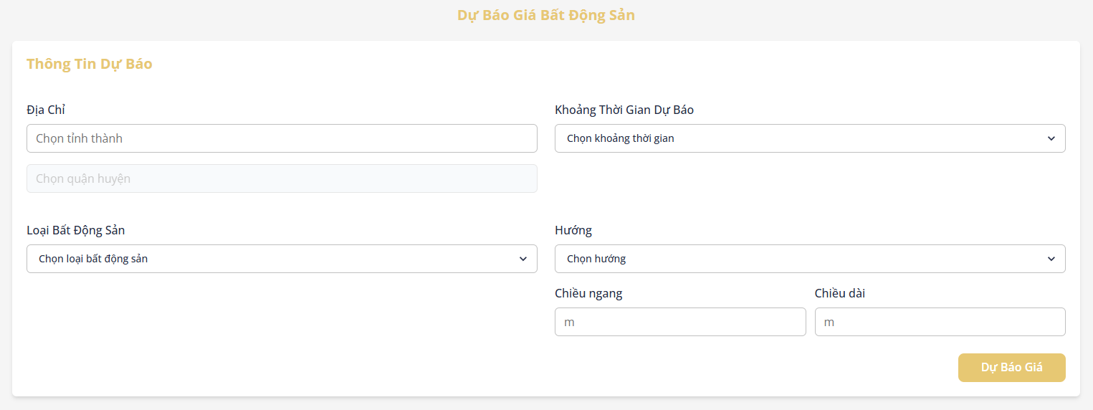

Figure . Property feature input interface for forecasting

* + The system will then display input fields corresponding to the property type chosen by the user.

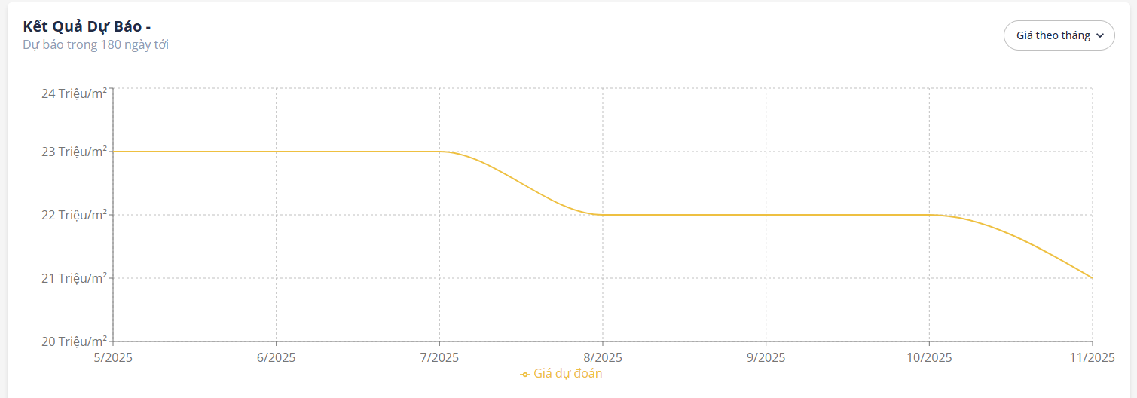

Figure . Forecast result interface

Table . Forecast property price function specification

|  |  |  |  |
| --- | --- | --- | --- |
| **Interface** | Forecast the property price | | |
| **Description** | Displays the interface that allows users to predict the property price in the future | | |
| **Access** | The user selects the “Dự báo” item from the user menu in the header | | |
| Interface Contents | | | |
| **Item** | **Type** | **Description** | |
| Chọn loại bất động sản | Selectbox | Select property category (land, house) | |
| Chọn tỉnh/thành | Selectbox | Select province/city | |
| Chọn quận/huyện | Selectbox | Select district | |
| Chọn khoảng thời gian | Selectbox | Select a time duration | |
| Loại hình đất | Selectbox | Select land type | |
| Đặc điểm đất | RadioCheckbox | Select land characteristics | |
| Hướng | Selectbox | Select property orientation | |
| Chiều ngang | Input | Enter land width (m) | |
| Chiều dài | Input | Enter land length (m) | |
| Số tầng | Input | Enter the number of floors | |
| Số phòng ngủ | Selectbox | Select the number of bedrooms | |
| Số phòng vệ sinh | Selectbox | Select the number of bathrooms | |
| Tình trạng nội thất | Selectbox | Select the property's interior status | |
| Dự đoán | Button | Button to forecast the property price | |
| **Actions** | | | |
| **Name** | **Description** | **Success** | **Failure** |
| Forecast real estate price | The user fills in property information and clicks the "Dự đoán" button to forecast the price. | The system processes the input and displays the predicted property price for the selected duration. | If required fields are missing or invalid, the system shows relevant error messages.  If an error occurs, display “Dự đoán thất bại” |

* **Account upgrade**

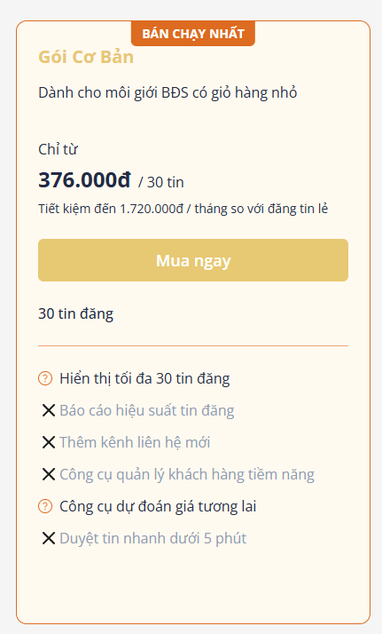

Figure . Upgrade account interface

* + When clicking the “Mua ngay” button, the user is redirected to the online payment page via VNPay, as shown below.

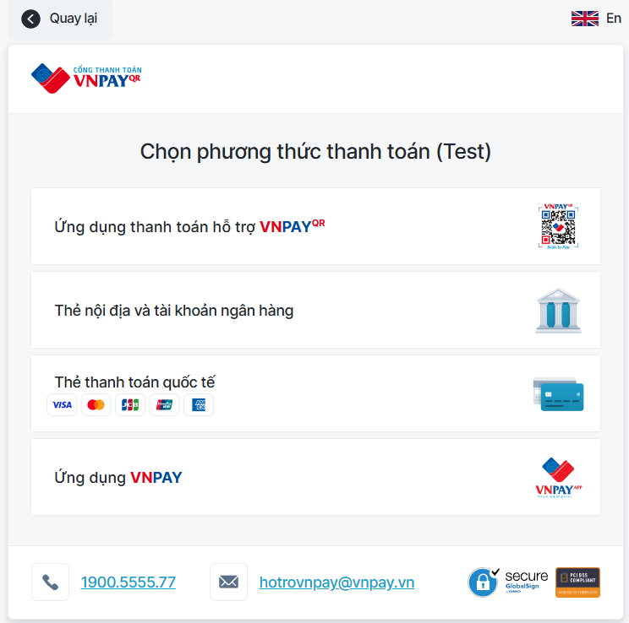

Figure . VNPay online payment gateway interface.

Table . Function specifications for upgrading the account

|  |  |  |  |
| --- | --- | --- | --- |
| **Interface** | Upgrade account | | |
| **Description** | Displays the interface that shows the list of upgrade account packages | | |
| **Access** | The user selects “Nâng cấp” from the user menu in the header. | | |
| Interface Contents | | | |
| **Item** | **Type** | **Description** | |
| Mua ngay | Button | Open the online payment gateway | |
| **Actions** | | | |
| **Name** | **Description** | **Success** | **Failure** |
| Upgrade account | The user selects a subscription package and proceeds to pay via VNPAY | The account is upgraded to a broker account, a transaction record is created and the system redirects to the transaction history page | If the user is not logged in, they are redirected to the login page.  If the selected package is lower than or equal to the current account level, the system displays the message “Tài khoản của bạn đã được nâng cấp lên gói vừa chọn hoặc cao hơn” |

* **Transaction history**

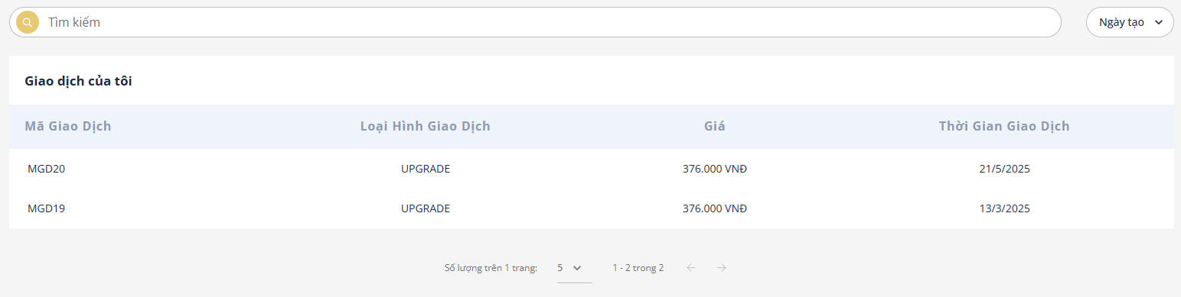

Figure . Transaction history interface

Table . Function specifications for showing transaction history

|  |  |  |  |
| --- | --- | --- | --- |
| **Interface** | Transaction history | | |
| **Description** | Displays the interface that shows the list of transactions | | |
| **Access** | The user selects “Lịch sử giao dịch” from the user menu in the header. | | |
| Interface Contents | | | |
| **Item** | **Type** | **Description** | |
| Sắp xếp theo | Selectbox | Select sorting criteria for the listings | |
| **Actions** | | | |
| **Name** | **Description** | **Success** | **Failure** |
| Sort listings | The user selects a sorting option from the dropdown | The system reorders the transaction listings based on the selected criteria | If sorting fails, the listing order remains unchanged and an error message is displayed |

### Admin-facing functionality

* Moderate posts

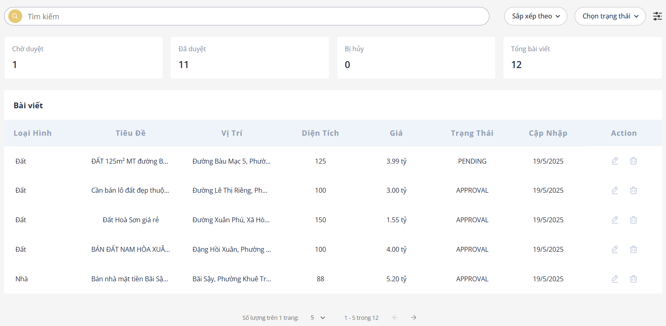

Figure . Post list interface

* + When the administrator clicks the edit button, the detailed information of the post will be displayed for moderation, as shown in the image below.

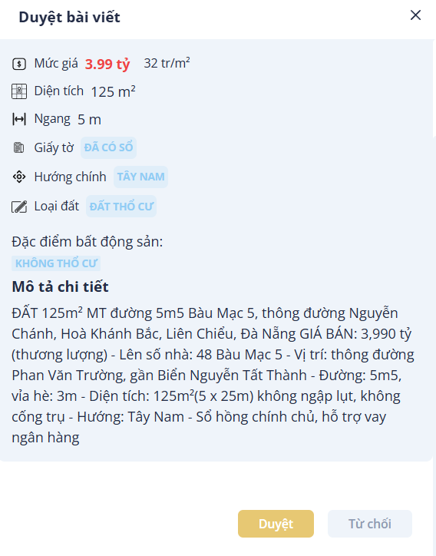

Figure . Post moderation interface

Table . Function specifications for post moderation

|  |  |  |  |
| --- | --- | --- | --- |
| **Interface** | Post moderation | | |
| **Description** | Displays the interface that shows the list of posts requested by the user. | | |
| **Access** | The user selects “Duyệt bài viết” from the user menu in the header. | | |
| Interface Contents | | | |
| **Item** | **Type** | **Description** | |
| Sắp xếp theo | Select | Select sorting criteria for the listings | |
| Chọn trạng thái | Select | Select the status of the post | |
| Pen icon | Button | Open a pop-up to review the post with detailed information | |
| Duyệt | Button | |  | | --- | |  |   Approve the post | |
| Từ chối | Button | Reject the post | |
| **Actions** | | | |
| **Name** | **Description** | **Success** | **Failure** |
| Filter posts | The user selects a filter option or enters a keyword to search for posts | Posts are filtered and displayed accordingly | Show message “Không tìm thấy bất động sản” if no matching property is found |
| Approve/Reject post | The user clicks the “Duyệt” or “Từ chối” button on a post | The post status is updated; approved posts appear in the user's post list | If the update fails, display the message “Cập nhật bài viết thất bại” |
| Select post | The user selects a specific post from the list for review | The post details are loaded for review | Show message “Không tìm thấy bất động sản” if details cannot be loaded |

|  |
| --- |
|  |

* Modify account status

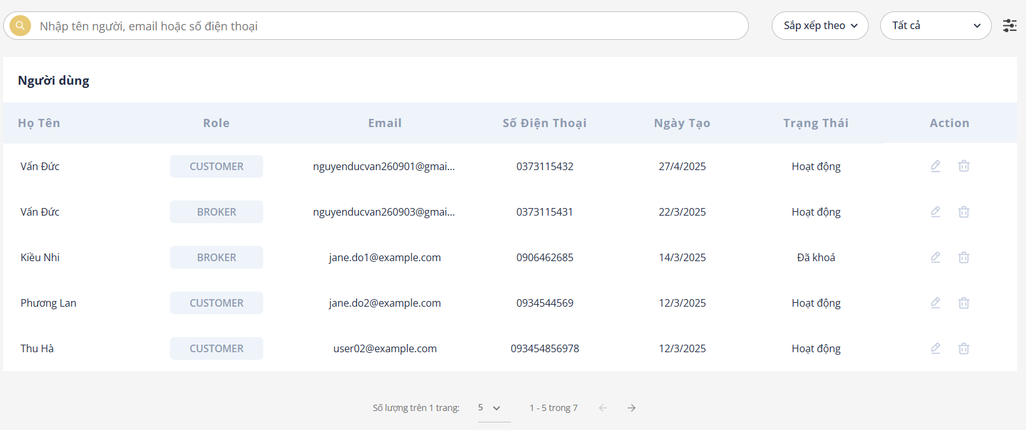

Figure . Account status modification interface

* + Clicks to update user status, a confirmation pop-up like this will be displayed.



Figure . User status change confirmation pop-up

Table . Function specifications for post moderation

|  |  |  |  |
| --- | --- | --- | --- |
| **Interface** | Post moderation | | |
| **Description** | Displays the interface that shows the list of posts requested by the user. | | |
| **Access** | The user selects “Duyệt bài viết” from the user menu in the header. | | |
| Interface Contents | | | |
| **Item** | **Type** | **Description** | |
| Sắp xếp theo | Select | Select sorting criteria for the listings | |
| Chọn trạng thái | Select | Select the status of the user | |
| Pen icon | Button | Open a pop-up to review the post with detailed information | |
| Đồng ý | Button | |  | | --- | |  |   Update user status | |
| **Actions** | | | |
| **Name** | **Description** | **Success** | **Failure** |
| Filter users | The user selects a filter option or enters a keyword to search for posts | Users are filtered and displayed accordingly | Show message “Không tìm thấy người dùng” if no matching user is found |
| Lock/Unlock user | When the confirm button is clicked, the user's status will be updated. | The user's status is updated. A locked user will no longer be able to log in. | If the update fails, display the message “Cập nhật người dùng thất bại” |

## Chapter conclusion

This chapter outlines the key requirements for deploying the website system and describes how the Price-support real estate business website operates in practice. It aims to give readers a clearer and more comprehensive understanding of how the system functions in a real-world environment.

# CONCLUSION AND DEVELOPMENT DIRECTION

## Achievements

During the research, theoretical study and system development process, the project has achieved several notable results:

* Theoretical Achievements
  + Gained a solid understanding of web development and applied technologies such as Java, React and Python to build a real estate website with price suggestion support.
  + Understood and implemented the MVC (Model-View-Controller) architecture in a real-world application.
  + Acquired the ability to analyze business processes, design system architecture and build a suitable database structure.
  + Learned how to process data, train machine learning models and integrate them into the system to suggest appropriate property prices.
* Practical Achievements
  + Successfully built and deployed the Price-support real estate business website, allowing users to search, post and explore property listings along with price reference features.
  + The basic machine learning model was implemented and is capable of providing initial price suggestions to support both buyers and sellers in making informed decisions.
  + Integrated AI functionalities to help moderate content and ensure uploaded images comply with content safety standards.

## Limitations

Despite the accomplishments, there are still several limitations in the current system:

* Login via Facebook and Google has not yet been implemented, which affects the user experience.
* Testing coverage is limited, making the system prone to bugs during real-world usage.
* The interface is not yet optimized for mobile devices, which limits accessibility.
* The prediction accuracy of the price suggestion model is still low and needs further improvement in both data quality and algorithm design.
* The UI/UX is not yet professional or user-friendly, requiring further refinement.
* Due to limited time and practical experience, the system analysis was basic and didn’t fully cover all use-case scenarios.
* The system includes only the core features and lacks many important supporting functions, which may impact overall usability and user satisfaction.

## Future Development

To improve the system and further enhance the project, the following development directions are proposed:

* Research and apply new technologies to enhance the accuracy of the price prediction model.
* Add Facebook and Google login to improve user convenience.
* Implement features such as comments, ratings and content reporting for better user engagement.
* Integrate Google Maps to visually display the exact location of properties.
* Add statistics and reporting tools for admins, such as view counts, number of listings, average prices by area, etc.
* Develop a chat interface between buyers and sellers to increase direct interaction.
* Improve the user interface with a modern, attractive and responsive design for a better user experience.
* Develop mobile versions of the application on Android/iOS platforms for broader accessibility and convenience.

# REFERENCES

<https://aws.amazon.com/vi/what-is/python/>

<https://200lab.io/blog/jupyter-notebook-la-gi>

<https://docs.jupyter.org/en/latest/what_is_jupyter.html>

<https://www.geeksforgeeks.org/introduction-to-java/>

<https://www.geeksforgeeks.org/spring-boot/>

https://viblo.asia/p/tat-tan-tat-ve-mo-hinh-mvc-Rk74avjAJeO

https://viblo.asia/p/luong-di-trong-spring-boot-ORNZqdELK0n

https://www.geeksforgeeks.org/what-is-mysql/

https://200lab.io/blog/reactjs-la-gi

https://www.geeksforgeeks.org/reactjs-introduction/

https://refine.dev/blog/chakra-ui/

# APPENDIX 1

# APPENDIX 2